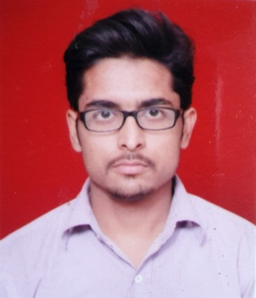

**SAIF ALI RIZVI**

ALI COLONY, QUILA,

BAREILLY, 243001

Mobile No. : +91-8923755569, +91-9528649942

E-mail : [rizvisaif11@gmail.co](mailto:ashir9368@gmail.com)m

**CAREER OBJECTIVE**

I seek a job as a Mechanical Engineer in a growing company where I can utilize my skills, abilities and knowledge.

I wish to contribute towards organizational goals through my technical knowledge, willingness to learn, hard work and creativity.

**ACADEMIA**

* **B.Tech** : Graduated from Shri Siddhi Vinayak Institute of Technology

Affiliated to Dr. A.P.J. Abdul Kalam Technical University, Lucknow,                U.P. with 76% marks (Honours) in 2017.

**Branch:-** Mechanical Engineering

* **XII**  : CBSE Board, Year of Passing- 2013
* **X**  : CBSE Board, Year of Passing- 2011

**SUMMER TRAINING EXPERIENCE**

* Title of the Project : Production system of Coca-Cola
* Company Name : Brindavan Beverages Pvt Ltd, Persakheda, Bareilly
* Designation : Trainee
* Training Duration : 30 days
* Key learning : Got a deep knowledge about company’s production                                       system.

**EXTRA CURRICULAR ACTIVITIES**

* Because of my strong interpersonal and team management skills, I was selected as Co-ordinator of Students’ Society of Mechanical Engineering of Shri Siddhi Vinayak Institute of Technology for the year 2014-15 & 2015-16.
* Received 2nd prize in “Quiz” competetion in year 2014-15.
* Received 2nd prize in “Sketch Making” competetion in year 2015-16.

**HOBBIES**

* Sketching
* Reading
* Listening to music

**AREA OF INTEREST**

* Refrigeration and Air-Conditioning
* Production And Manufacturing

**STRENGTH**

* Leadership quality
* Adaptable in team environment
* Good communication skills

**PERSONAL DETAIL**

* Date of Birth : 25/Nov/1995
* Father’s Name : Firoz Hussain Rizvi
* Nationality : Indian
* Language known : English and Hindi

**Date** :

**Place:** Bareilly, U.P (**SAIF ALI RIZVI)**