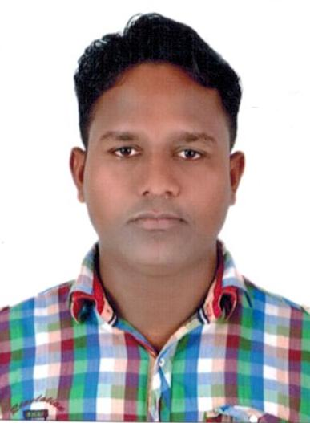**CURRICULUM VITAE**

**DEEPAK KUMAR RAM**

* **+971 568076800**
* **+971 558541497**

**Dubai UAE**

* **+91 7779958893**

**India**

**Email: deepakkumar166109@gmail.com**

**POST APPLIED FOR: “Plumber”**

**OBJECTIVE**

A Suitable position with an organization where I can Utilize the best of my skills and abilities that fit to my Education, skills and experience a place where an encouraged and permitted to be an active participant as well vital contribute on development of the Company

**PERSONAL PROFILES:**

Name : **DEEPAK KUMAR RAM**

Father’s Name : Vijay Ram

Date of Birth : 31-07-1988

Nationality : Indian

Gender : Male

Religion : Hindu

Marital Status : Single

Languages Known : English & Hindi

**Passport DETAILS:**

Passport No : J 0623931

Date of Issue : 05-03-2010

Date of Expiry : 04-03-2020

Visa Status : Employment Visa

**Education Qualification:**

* Matric Passed

**Professional skills:**

* Waters supply
* Drainage line
* Sanitary fitting

**EXPERIENCE:**

* Presently working as a **“Plumber ”** with **Electromech Technical Associates Co Llc**, Dubai UAE from November 2011 to till date.
* Worked as a **“Plumber ”** in India for the period of 2 years.

**CONCLUSION & DECLARATION:**

I here by certify that the above mentioned Statement is correct & true to the best of my knowledge & belief.

**DEEPAK KUMAR RAM**