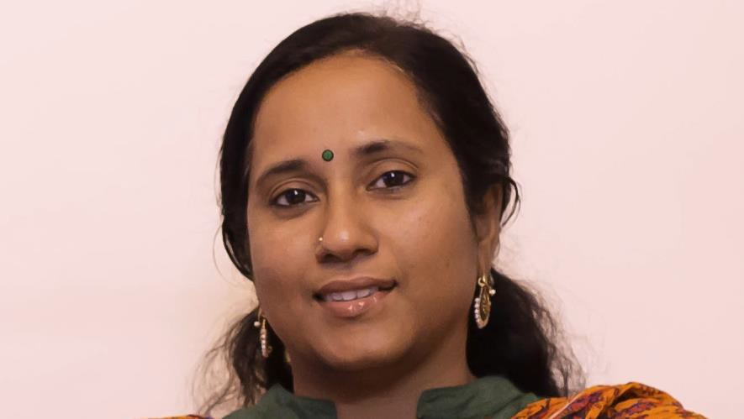

|  |  |
| --- | --- |
| **R RAJESWARI** | **RESUME** |

**Resume**

**Summary**

Attentive Middle School Math Teacher with excellent communication skills. Organized and driven with the innate ability to stay on task. Uses effective and efficient methods of teaching whilst focusing on the individual needs of each student.

# Highlights

* Lesson planning expertise
* Academic performance evaluation
* Common core knowledge
* Strong communication & analytical skills
* Student motivation
* Use of aids (Math lab, smart board etc.) to give concrete idea of the concepts to the students

# Experience

* Six years as a Math teacher with Patel Public School, Bellandur, Bengaluru (From June 2010 till March 2016)
* One year+ as a Math Curriculam Team Member with Chrysalis High Chain of Schools (CBSE), Bengaluru (From May 2016 to June 2017)
* Presently working as a Cue Math Teacher Partner from August 2017
* X Std ICSE Board examination - paper evaluation (2014-2015)
* X Std ICSE Board Exam Invigilator for 4 years
* Attended Math workshop (six sessions) conducted by Azim Premji University
* Attended Math workshops conducted by Oxford press and Madhuban publications
* Conducted & organizing teacher for Prathiba Vignan Math talent exam for the last 6 years
* Member – School examination committee for the last 3 years

# Academic Qualifications

* Masters in Math from Manonmaniam Sundaranar University, May 2016 (First Class)
* Bachelor of Math from University of Madras with 85% (1997)
* Bachelor of Education from Bhartidasan University with 77% (2014)

# Personal Summary

Date of Birth : 25th July

Languages Known : English, Tamil & Hindi

E-mail id : [rajiswamy77@gmail.com](mailto:rajiswamy77@gmail.com)

Contact no. : 98416 80404

Flat G3, Dynamic Flats, No.3, 3rd Main Road, Nanganallur, Chennai 600 061.