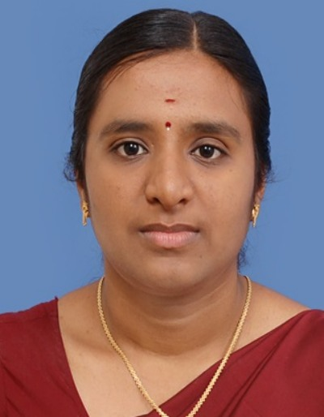**S.Lavanya**

**M.E (Computer Science)**

Email : s.lavanya.me@gmail.com

Mobile : +91 - 9500735196

**OBJECTIVE:**

To endure my teaching career at a highly-reputed and eminent educational institute and to gain exceptional career move ahead through long efforts and performance regularity.

# EDUCATIONAL QUALIFICATION:

|  |  |  |  |  |
| --- | --- | --- | --- | --- |
| **S.NO** | **QUALIFICATION** | **INSTITUTION** | **SCORE** | **PERIOD** |
| 1. | M.E,  Computer Science  And Engineering | Government College Of  Technology,  Coimbatore. | CGPA-8.83 | 2010-2012 |
| 2. | B.Tech,  Information  Technology | Anjalai Ammal-Mahalingam  Engineering College,  Kovilvenni,  Tiruvarur. | 83.6% | 2006–2010 |
| 3. | Higher  Secondary | A.R.R Matriculation HSS,  Kumbakonam | 83.5% | 2005-2006 |
| 4. | S.S.L.C | A.R.R Matriculation HSS,  Kumbakonam | 91.36% | 2003-2004 |

**TEACHING EXPERIENCE:**

Worked as an Assistant Professsor in Computer Science Department at Hindusthan College of Engineering and Technology, Coimbatore from April 2012 to May 2013.

**SUBJECTS TAUGHT:**

* Fundamentals of Programming and computing
* Cryptography and Network security
* Microprocessor and Microcontroller

**TECHNICAL SKILLS:**

Programming Languages : C, C++, Java

**AREAS OF INTEREST:**

* Cryptography and Network security

# ACADEMIC PERFORMANCE:

* Got 100% result in the classes handled

# SOFT SKILLS:

* Good team player
* Good comperer.

# PAPER PRESENTED :

* Presented a paper on “Efficient Architecture for Secure Group Key Management” at Government college of Technology, Coimbatore.
* Presented a paper on “Clustering Based Approach for Outlier Detection” at Government college of Technology, Coimbatore.
* Presented a paper on “Grid computing” at Anjalai Ammal- Mahalingam Engineering College.
* Presented a paper on “Remote File Transfer ” at Arasu Engineering College.
* Presented a paper on “Spintronics” at HSL.

# TRAINING PROGRAMS ATTENDED :

* Workshop on Art of Computing organized by Department of Computer Science at PSG College of Technology.
* “Capacity Building for Industrial needs” conducted by TamilNadu Government.
* Soft Skill Training Programme conducted by TUV RHEINLAND Academy.
* Workshop on “Research issues in Wireless and Sensor Networks” organized by Department of CSE , Hindusthan College of Engineering and Technology.
* Seminar on “Network Administration” at Hindusthan College of Engineering and Technology.
* Faculty Development Programme on “Free/Open Source Software Educational Programs” at Hindusthan College of Engineering and Technology.

# ACTIVITIES PERFORMED :

* Organized the national level technical symposium “INNOMOTIVA” in Anjalai Ammal-Mahalingam Engineering College.
* Committee member in national conference (NCVIT’11) conducted in Government College of Technology.
* Conducted seminar in workshop “Recharging Network Concepts” in Government College of Technology.

# Personal Details

Name : S.Lavanya

Status : Married

Date of Birth : 29.06.1989

Address : F2-B, plot no:4,

Gangai street, 2nd main road,

Thiruthani nagar,

Zamin Pallavaram,

Chennai-600117.

**DECLARATION:**

I hereby declare that the information furnished above is true to the best of my knowledge.

PLACE : Chennai

DATE : 21.2.2018

(S.Lavanya)