**‘ R E S U M E ’**

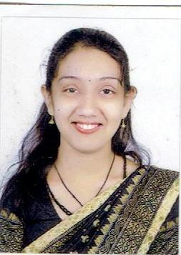

Name : **R. Sowmya**

Husband’s Name : Mr. Sriman Narayanan C

Date of Birth : 10-12-1992

Present Address : Kailash Apartment,

Old No.26, New No.32,

Kanniga Colony,

4TH Street, Nanganallur,

Chennai - 600 061 (T.N.)

**Mob.No. : 9717570779**

email: sowmya10121992@gmail.

Educational Qualifications : B.A – from Delhi University – 2014.

ETE from Manvi Institute of Training,

New Delhi – 2016.

Higher Secondary – Himalaya Public School,

New Delhi -2011.

Secondary – Himalaya Public School,

New Delhi – 2009.

Professional Qualifications : Did Sr. Diploma (Sangeeta Bhusan) in Carnatic

Music (Vocal) from PRACHEEN KALA KENDRA,

Chandigarh.

Presently pursuing (SANGEET VIBHUSHAN)

in Carnatic Music from PRACHEEN KALA

KENDRA, Chandigarh.

Did 2 Yrs Diploma Course in TEACHER’S

TRAINING from recognized board (SCERT).

**Contd…2/-**

**-2-**

**Professional Experience : 5 years**

Have experience of Teacher Practice (TP) during the training period in MCD schools namely :

* Nagar Nigam Pratmik Vidyalaya, X-block Mangolpuri, Delhi.(Also organized programme on festivals like (Republic Day / Christmas) etc.
* Nagar Nigam Pratmik Vidyalaya, Sec-25 Rohini, Delhi.
* 2 years experience at SDBM (Saraswati devi bal mandir) Rajeev nagar, Delhi.
* 1 year experience at **Adriel High School,**  Sec-24, Rohini, Delhi.
* Attended CCE & CCA Workshop .
* Attended workshops from various publishers like Pearson, Cambridge, Mcmillan.
* Attended AMPS workshop held at Coimbatore.
* Presently working at R.K.V C.B.S.E Secondary school. Coimbatore as HoD in Hindi Department. I have organized many programmes / seminar in this school.

**Languages known**

Tamil, English, Hindi

**Hobbies**

Listening music, Singing, Teaching, Drawing &Paintings. I am passionate about my work right from childhood and would like to attain perfection in all the areas whatever assigned to me. I have positive outlook towards life. I want to educate each & every child, sincere and honestly.

**Objective**

Seeking a position to utilize my teaching skills and abilities. A job where growth prospects are unlimited and individuality is recognized by work, and to achieve professional satisfaction by meeting higher responsibilities and involving in competent work areas

**(R. SOWMYA)**