**RESUME**

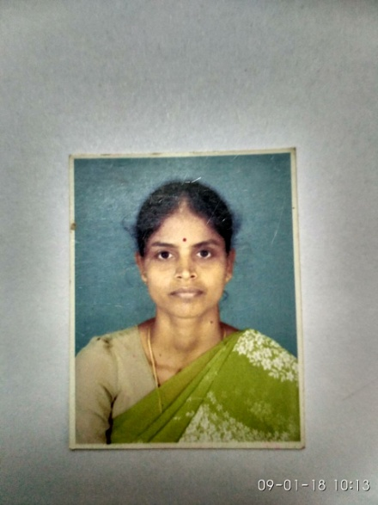**DEGREE : B.lit, M.A,M.Phil**

**SUBJECT :Tamil**

**PERSONAL DETAILS**

**NAME**  : REVATHI

**RESIDENTIAL ADDRESS:**

No.4, G.C.R.Nagar, 4th street

Gobichettipalayam

Erode – 638 452

Phone: 8508727021

E-mail:[revathyananthi2404@gmail.com](mailto:Revathyananthi2404@gmail.com)

**DATE OF BIRTH :** 24-04-1975 **AGE**: 42 **SEX**: Female

**SPOUSE NAME** **:** Viswanathan S

**MOTHER TONGUE :** Tamil

**LANGUAGES**  **: Read** : English, Tamil, Hindi, Sanskrit

**Write** : English, Tamil, Hindi, Sanskrit

**Speak** : Tamil

**ACADEMIC RECORD**

|  |  |  |  |  |
| --- | --- | --- | --- | --- |
| **Course** | **Institution** | **Board /**  **University** | **Year of**  **Completion** | **Marks %**  **/ CGPA** |
| X  XII  B.lit | Bhavani Girl’s High School,Bhavani  .  Bhavani Girl’s High school, Bhavani  .  Annamalai University. Chidambaram | State Board  State Board  Annamalai University | 1990  1992  2009 | 55  67.5  First class |

**PROFICIENCIES:**

**Typing :** English and tamil

**Packages**  : Microsoft Office 2013, MATLAB

**Platforms Used** : Microsoft Windows XP / 7 / 8

**EXPERIENCE DETAILS:**

|  |  |  |
| --- | --- | --- |
| **Name of the School** | **Duration** | **Handled subjects and Standards** |
| Kongu Matriculation Higher Secondary School, Kunnathur.  Hema Bala Bhavan Matriculation school, Chennai  Saratha Matriculation Higher Secondary School, Gobichettipalayam  Saratha International school, Kodiveri | 6 years    4 years  9 years  3 years | Tamil- 6th to 8th.  Tamil- 6th-8th  Tamil – 8th to 10th , Sanskrit-11th to 12th  Tamil – 6th -10th, Sanskrit- 11th-12th |

**CURRENT SALARY PACKAGE :** Rs.30,000-/- per month.

**CO-CURICULAR AND EXTRA-CURICULAR ACTIVITIES**

* Completed Yoga course from Vazhum Kalai
* Good tamil typist
* Completed diplamo computer course
* Have taken classes for competitive exam preparations (TNPSC group exams)
* Awarded as a Best Teacher in the academic year 2010-2011.

**HOBBIES:**

* Doing Yoga
* Reading books

I, **REVATHI R,** do hereby confirm that the information given above is true to the best of my knowledge.

Date:

Place: SIGNATURE

**______________________**

(REVATHY R)