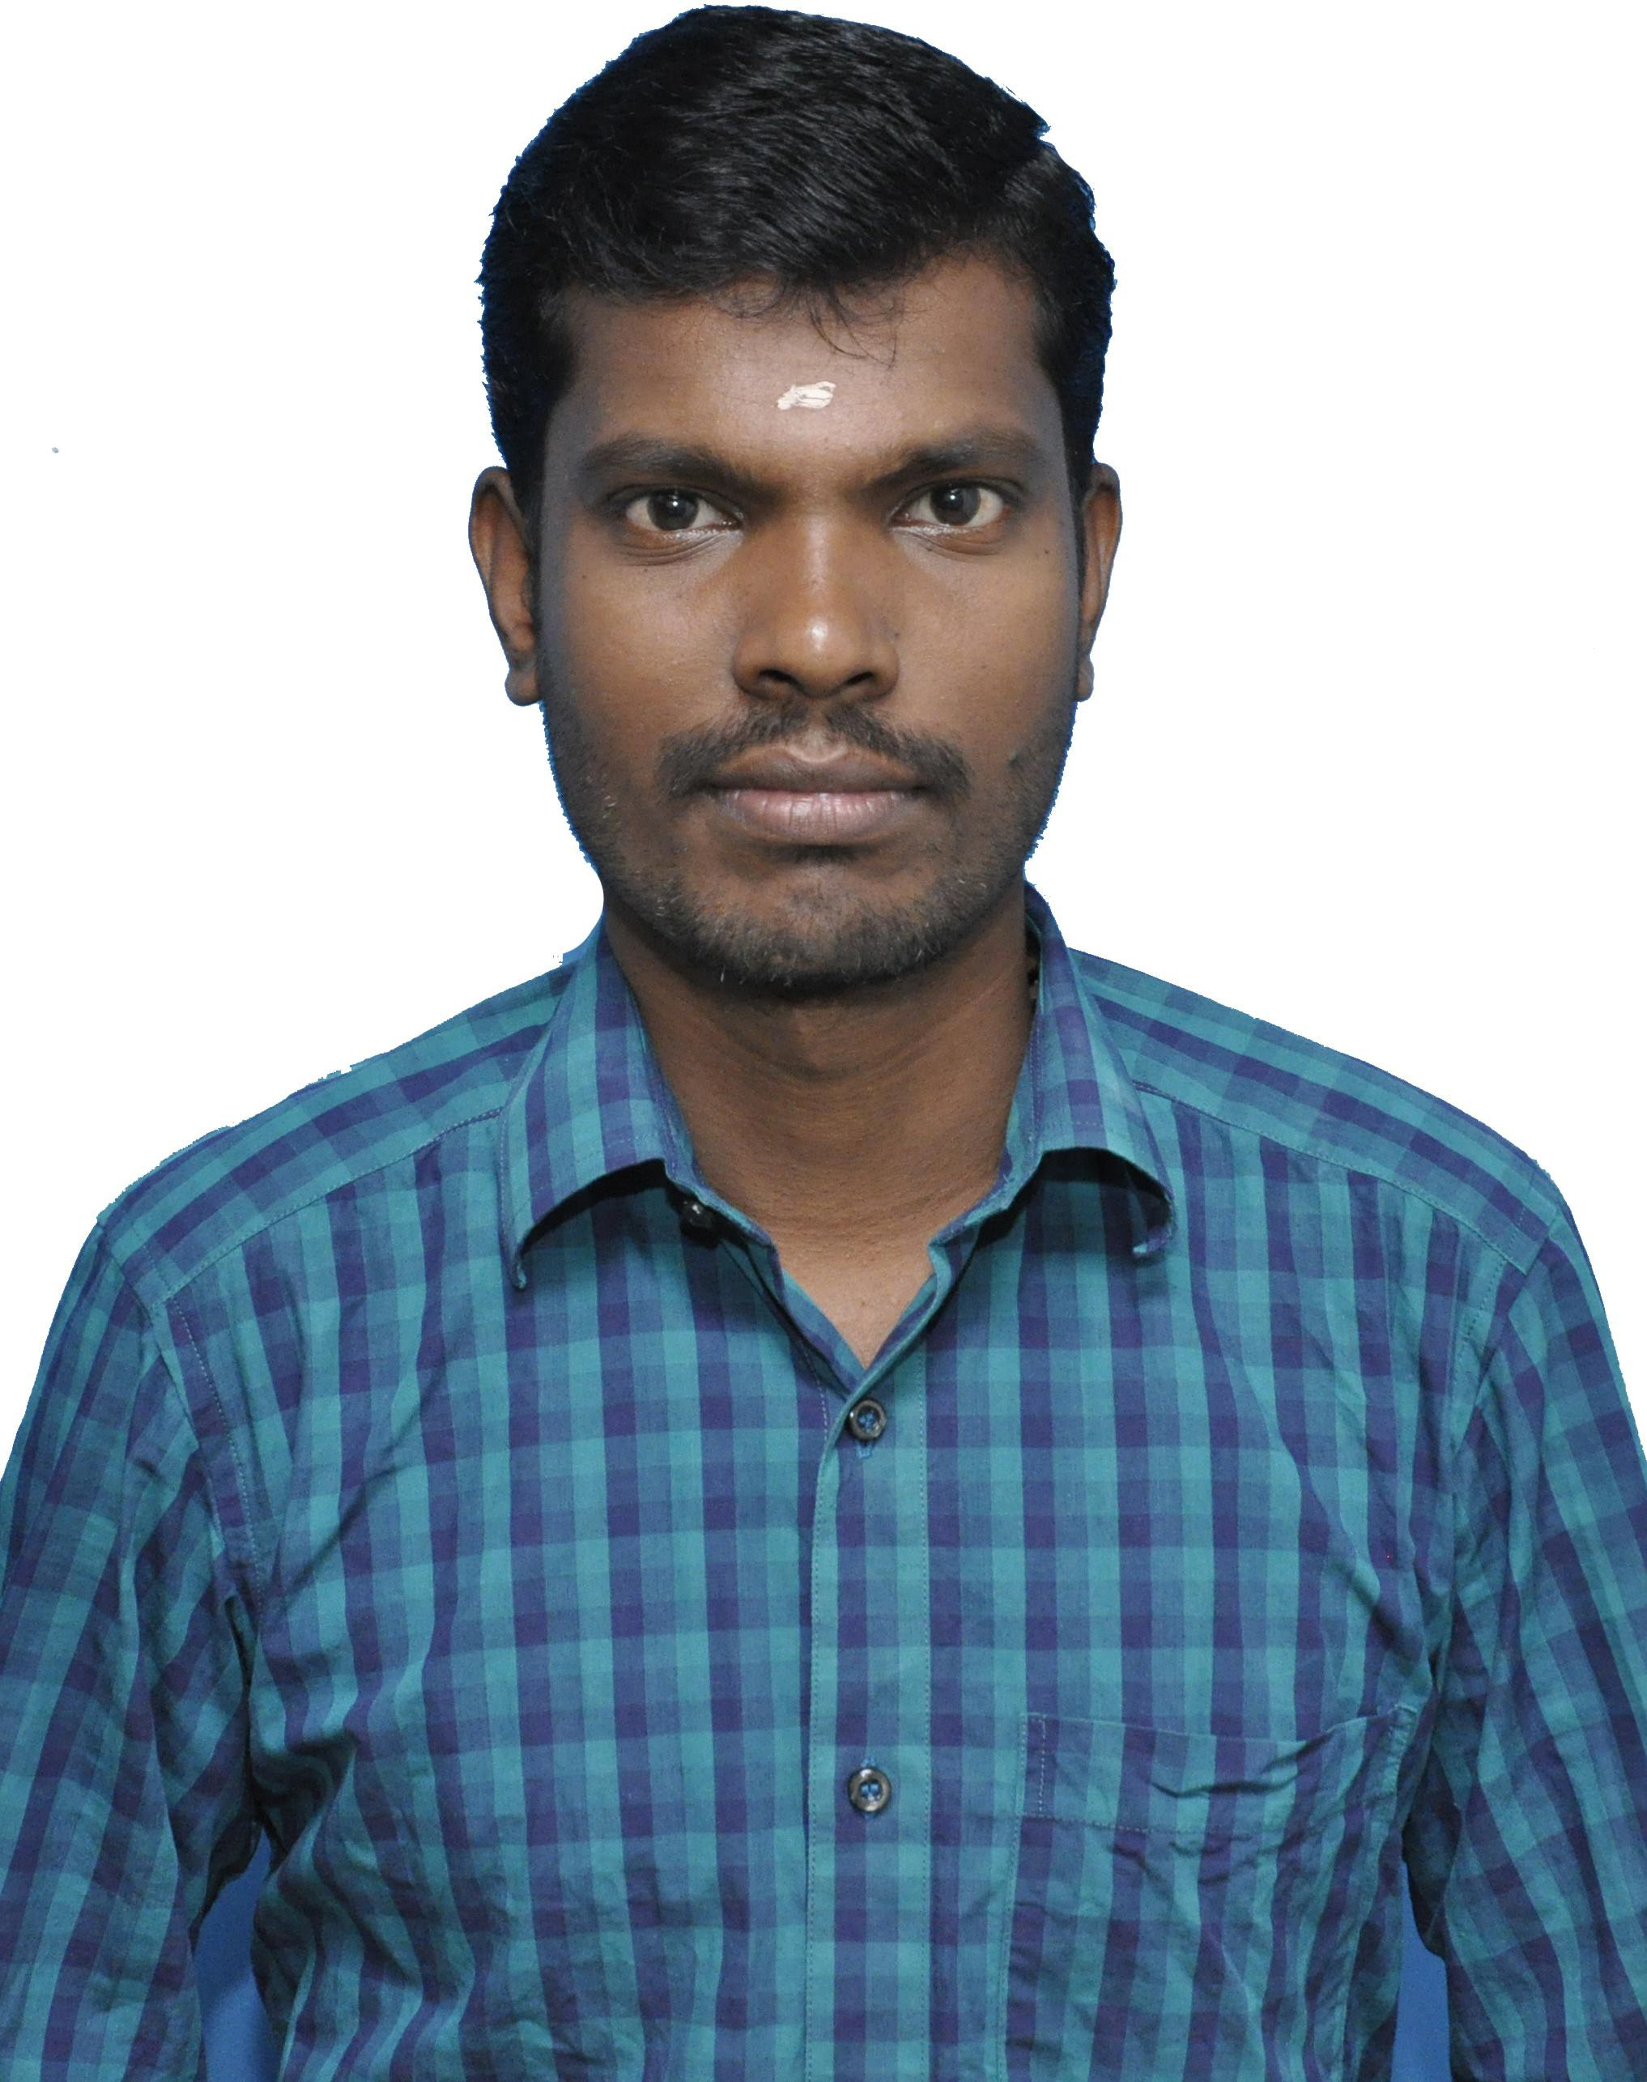**Karthik Mahalingam**

Mobile: +91 9500475127

Email: [karthikmagalingam@gmail.com](mailto:karthikmagalingam@gmail.com) Web: [www.orgatesoftware.com](http://www.orgatesoftware.com/)

# Objective

To succeed in an environment of growth and excellence and earn a job which

provide me job satisfaction and self-development and help me achieve personal as well as organizational goals.

# Technical Skills

Operating System Win 2003 /XP, Windows7, Windows8, Windows10,

Windows Server2003, 2008, 2012,2016

Languages C, C++, java, Asp.net, Dreamweaver

Data Base MS Sql Server 2005

Markup Scripting/Design Html, Photoshop, Corel Draw

Office Products Microsoft Access, Excel, Word, Outlook

# Core Technical Skills

* **VLAN**
* **Active Directory Services,**
* **Group Policy Management Console,**
* **Hyper V**
* **Web designing**
* **Design, develop and manage software projects for clients.**
* **Develop Microsoft .net based web applications.**
* **Modify and update existing technologies improvise performances.**
* **Install, upgrade, support and troubleshoot XP, Windows 7, Windows 8 and Windows Server**
* **Setting up and configuring new laptops and desktops.**
* **Install, upgrade, support and troubleshoot for printers, computer hardware.**
* **Performs maintenance tasks on computers, laptops, printers.**
* **Networking**
* **Responsible for monitoring, operating, managing, troubleshooting and restoring.**
* **Service any client, personal computers (PC) or notebooks.**

Able to work in rotating Shift, Can work extra hours to meet deadlines, as required and where reasonable.

# Work Experiences

Organization : Orgate Software- Coimbatore Designation : Customer Support Engineer Duration : July 2012 to Dec 2012 Responsibilities

* **Going to different customer places on call basis addressing the calls and resolving them**
* **Installing and troubleshooting Windows 7 / XP / 2003 Server operating system.**
* **Troubleshooting of LAN, Workstation.**
* **Configuring of wireless LAN, support Hardware and software issues of workstations.**
* **Assembling & Installation New PC’s, PC upgrades, Printers and new software’s as needed.**
* **Troubleshooting Servers, Desktops, Printers, and other peripherals etc.**

Organization : Genius Consultants Pvt.Ltd -Chennai Designation : Operation Executive

Duration : Jan 2013 to June 2013

Served as Operation Executive for TATA CONSULTANCY SERVICES-CHENNAI

Organization : Coreintegra Consultants Pvt.Ltd -Mumbai Designation : Operation Executive

Duration : July 2013 to April 2014

Served as Operation Executive for TATA CONSULTANCY SERVICES-CHENNAI (Same Vendors but Different Consultancy)

# Responsibilities

* **Supporting to Online Assessment.**
* **Installing and troubleshooting Windows 7 / XP / 2003, 2008 Server operating system.**
* **Configuring of Examination server,**
* **Support Hardware and software issues of workstations.**
* **Troubleshooting Examination Server.**

Organization : Prist University-Thanjavur Designation : Asst System Manager Duration : Aug 2015 to March 2018

# Responsibilities

* **Handle and resolve help desk tickets and escalate to IT Manager when necessary**
* **Server management**
* **Virus and malware removal skills**
* **Identify, interpret, and evaluate systems and network requirements**
* **Support remote users via remote control software and telephone**
* **Assist in installation of computer and networking hardware**
* **Assist in monitoring network performance, security and IT infrastructure**
* **Assist in recommending improvements to systems and network configurations, determines hardware or software requirements**
* **Other duties may be assigned as required**
* **Assembling & Installation New PC’s, PC upgrades, Printers and new software’s as needed**

Organization : Velammal Bodhi Campus-Thanjavur Designation : System Admin

Duration : April 2018 to till Date

* **Server management**
* **Virus and malware removal skills**
* **Support remote users via remote control software and telephone**
* **Assist in installation of computer and networking hardware**
* **Assist in monitoring network performance, security and IT infrastructure**
* **Assist in recommending improvements to systems and network configurations, determines hardware or software requirements**
* **CCTV Camera and smart Board Maintain**
* **Assembling & Installation New PC’s, PC upgrades, Printers and new software’s as needed**

# Educational Qualification

|  |  |  |
| --- | --- | --- |
| **2012** | **MCA, Sastra University, Thanjavur** | **68%** |
| **2010** | **B.sc (IT)Bharath College, Thanjavur** | **68%** |
| **2007** | **HSC, Govt.Boys.Higher Secondary School, Vallam** | **57%** |
| **2005** | **SSLC, Govt.High.School, Alakkudi** | **42%** |

**Personal Details**

Father Name : Mahalingam T

Date of Birth : 10-May-1990

Sex : Male

Marital Status : Single

Languages Known : English, Tamil

Nationality : Indian

Passport Number : Z2717841

Driving Licence : TN49 20150003053-MCYCLE WG/LMV Permanent Address : # 315, LF Main Road,

Alakkudi-Post, Thanjavur-Dt Pin-613601

# Declaration

I hereby declare that all the information provided above is true to the best of my knowledge and belief

You’re faithfully Karthik Mahalingam