**ASWINI R**

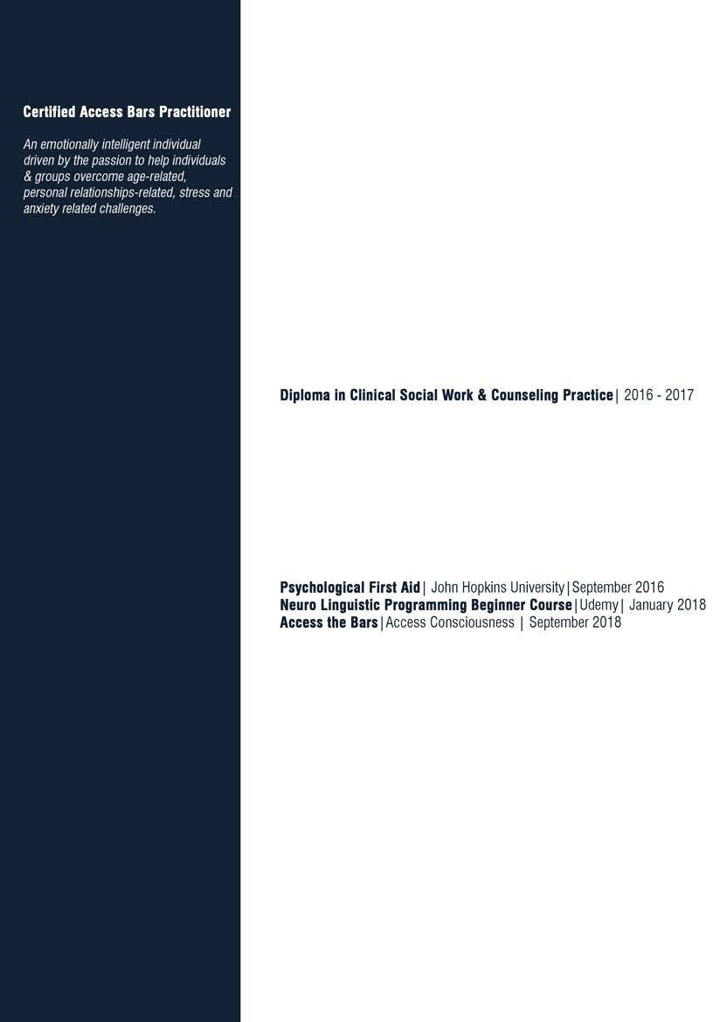

**Psychological Counselor**

CONTACT ME

+91 98468 96648

[ashwiniram009@gmail.com](mailto:ashwiniram009@gmail.com) Sri Lakshmi, 12 A,

Jayanti Nagar 2nd Street, 6th Main Road, Nanganallur, Chennai - 600 061.

INTERPERSONAL SKILLS

Quick Learner Growth Mindset Active Listener

Strong Communication Goal setter & Go-getter Self-led personality

English Tamil Malayalam Hindi

HOBBIES & INTERESTS

**Avid Reader**

Self-help, Spirituality & Non-fiction

## Arts Enthusiast

Pencil drawing, handicrafts & Origami

## Fitness Enthusiast

Yoga, Meditation & Aerobics

## Cooking Aficionado

North Indian & South Indian

# INTERNSHIP EXPERIENCE

## Jana Seva Sishu Bhavan, Aluva (April'17 to May'17)

Mentored and counseled 150+ girl children about self-protection, child & women rights, importance of higher education and career possibilities.

## M.S.Swaminathan Research Foundation (May'15 to June'15)

To study about the educational rights of tribal children at Wayanad. The steps fol- lowed in a research & to conduct an interactive session with students.

## Shanthi Ashram (May'14 to June'14)

Worked with social workers, academicians. teachers and students to gain an in-depth understanding of present day child rights and its various aspects.

# EDUCATION

Rajagiri College of Social Sciences, Kalamassery, Ernakulam.

**Masters in Social Work (MSW) I** 2013 - 2015

Amrita Vishwa Vidhyapeetham, Coimbatore.

**BSc. MicrobiologyI** 2010 - 2013

Sri Ramakrishna College of Arts and Science for Women, Coimbatore

# PROFESSIONAL CERTIFICATIONS

ACADEMIC ACTIVITIES UNDERTAKEN

## PROJECT: Menstrual Hygienic Practices among adolescent girls

Amrita Vidyalayam, Ettimadai, Coimbatore (Jan'15 to April'15)

**SEMINARS PLANNED & ORGANIZED:**

* + 2 day training programme on 'Anti human trafficking' conducted by International Justice Mission (IJM)
  + Hosted training programme on 'Online Safety For Children' by Aarambh
  + Workshop on 'Participatory Rural Appraisal (PRA)'
  + 3rd National Conference of Institute for Person Centered Approaches in India
  + Cognitive Behavioral Therapy organized by Rajagiri School of Sciences

## FIELD WORK UNDERTAKEN

* + 5 Months field work training in 'Helpage India' NGO, Coimbatore. (1st Sem)
  + 6 Months field work training in Amrita Vidhyalayam School & Ettimadai Community, Coimbatore.(2nd Sem)
  + One year Field work training in Dist., Child Protection Office and National Child Labor Project, Coimbatore. (3rd and 4th Sem)
  + 8 months volunteered for 'Save The Globe' NGO