# CURRICULUM VITAE

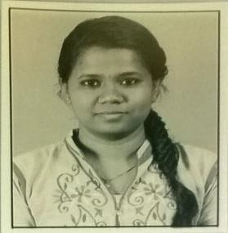**JENNIFER D J**

F2, Royce Enclave Flats,

No ½, Chozhapuram, Fifth Street, Ambattur,

Chennai – 600053, Tamil Nadu, India E-mail ID: [**jenni.roque1@gmail.com**](mailto:jenni.roque1@gmail.com)Mobile : **+91- 8056203764**

**OBJECTIVE** To establish myself in the field of teaching so that I can use and spread the knowledge that I gained for

|  |  |  |  |
| --- | --- | --- | --- |
| the bright future of students and betterment. | also for | my | own |
| **M.Phil Mathematics, 2017** | **76.6%** |  |  |
| College of Engineering, Guindy, (Anna University) |  |  |  |
| **M.Sc Mathematics, 2016** | 7**5.25%** |  |  |
| Stella Maris College, Chennai, |  |  |  |
| (University of Madras) |  |  |  |
| **B.Sc Mathematics, 2014** | **73.5%** |  |  |
| Stella Maris College, Chennai, |  |  |  |
| (University of Madras) |  |  |  |

**EDUCATION**

**ACHIEVEMENTS** Holder of NCC “B” Certificate with grade C

Holder of NCC “C” Certificate with grade A Awarded Best CADO Leader of Stella Maris NCC COY

**PROJECTS** 1. A Study on Orbital Mechanics (Internship Project)

1. Design of a Humanoid Robot Involving Control Technique (Dissertation Project)
2. A Study on Efficiently Secure Dominatable Graphs (M.Phil Project)

**LANGUAGES KNOWN** English, Tamil

**SKILLS** Ability to work with people Good presentation skills Good teaching skills

Good Communication skills

**TECHNICAL KNOWLEDGE** Microsoft word, Excel, PowerPoint Presentation, Internet Savvy.

**EXPERIENCE** RAVINDRA BHARATHI GLOBAL SCHOOL,

MOGAPPAIR (June,2018- present)

|  |  |
| --- | --- |
| **PERSONAL DETAILS** | |
| Age | : 24 years |
| Date of Birth | : 15-11-1993 |
| Gender | : Female |
| Email ID | : [jenni.roque1@gmail.com](mailto:jenni.roque1@gmail.com) |
| Mobile | : +91 8056203764 |

# DECLARATION

I hereby declare that the above particulars are true to best of my knowledge and belief.

Place : Chennai 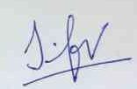 Date : 09-02-2019

**JENNIFER DJ**