

**Passport Details: Passport No : N4469844 Date of Issue : 09/11/2015**

**Date of Expiry: 08/11/2025**



# Contact Details:



**Mail ID:** [**triplem1826@gmail.com**](mailto:triplem1826@gmail.com) **Contact No: 07904493174 Address:**

## 67/30, Attakkulam Street, KadayanallurTk, Tirunelveli Dt - 627751, Tamilnadu, India

**Personal Data:**

**Father Name:**

M S MOHAMED IQBAL

**Date of Birth:** 26/07/1995

**Gender:** Male **Nationality:** Indian **Marital status:** Single **Languages Known:** English & Tamil **Driving License:**

## Indian Driving License, Light

**Hobbies:**

Playing cricket & Reading Books

To associate myself with a professionally driven reputed organization by pursuing a challenging, responsible and rewarding career and applying my skills and enthusiasm which would enhance my career development and contribute to the progress of the organization and the society as well.



* **Bachelors of Engineering** in **CIVIL ENGINEERING** at **NATIONAL COLLEGE OF ENGINEERING, MARUTHAKULAM, TIRUNELVELI** with FIRST CLASS **(CGPA of 6.63/10)** (Year of passing -2016)
* **Diploma** in **PG** in **QUANTITY SURVEYING AND VALUATION at ANNAMALAI UNIVERSITY** with the percentage of **43.75 %** (Year of passing - 2016)
* **HSC** in **DARUSSALAM HIGHER SECONDARY SCHOOL**

with the percentage of **77.25 %** (Year of passing -2012)

* **SSLC** in **DARUSSALAM HIGHER SECONDARY SCHOOL** with the percentage of **87.8 %** (Year of passing - 2010)



* Goal oriented and self-motivated
* Excellent interpersonal skills
* Efficiency of managing multiple tasks
* Hard working and flexible to work in shifts
* Strong learning & Grasping ability
* Easy goer and Good leader



* Auto CAD
* 3ds Max
* Land Survey
* Quantity Take Off
* Desktop Publishing
* Hardware Design
* MS Office



* Use effective strategies to minimize risks.
* Well verse with safety procedure.



* Project on the topic of “**STABLIZATION OF CLAY SOIL BY USING WASTE RUBBER TYRE**” by team of four members at NATIONAL COLLEGE OF ENGINEERING, MARUTHAKULAM, TIRUNELVELI
* Mini Project on the topic of “**ANALYSIS AND DESIGNING OF APARTMENT BUILDING**” by the team of four members at NATIONAL COLLEGE OF ENGINEERING, MARUTHAKULAM, TIRUNELVELI



* + COMPANY NAME : S R BUILDERS
  + PLACE : MADURAI
  + SITE : Complex
  + ROLE : Site supervisor
  + DURATION : **(June 2016 - September 2017)**



* Making Daily Routine Inspection at Work Site
* Keep A Record of All Safety Meeting
* Keep Record of Injuries, property damages and Fire
* Supervision of all construction works on site
* Daily inspection of crane and scaffolding
* Make monthly inspection of moving equipments and ladder etc.,
* Inspection of necessary work permit whenever to begin the job
* Put necessary safety precaution before starting any job
* Monitor all workers if they are wearing safety paraphernalia at job site
* Make daily reports regarding safety in the job
* Advise the workers for Chemical Hazards and use of proper PPE
* Closely observation to make sure that first aid welfare facilities properly maintained
* Equipments are provided and properly worn
* Preparation of daily safety reports
* Reminding all workers that the safety in the best policy and to target zero accident



I hereby declare that the information cited above is true to the best of my knowledge.

Yours Faithfully,

**(MOHAMED ANAS M M)**

**PHOTO:**

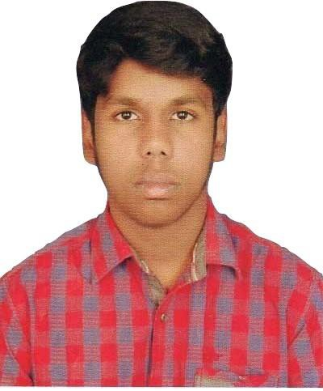

**PASSPORT COPY:**

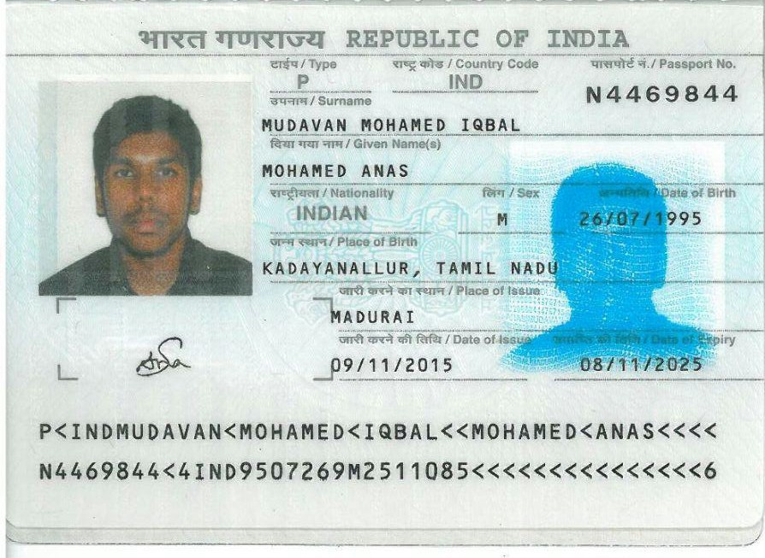

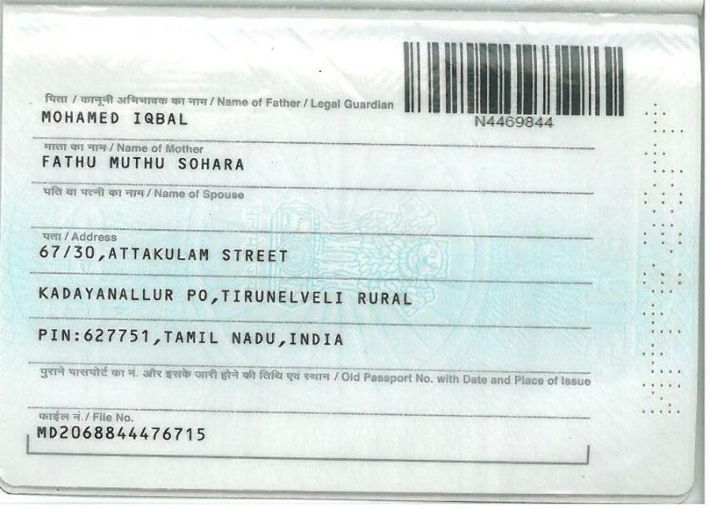

**DEGREE SCAN COPY:**

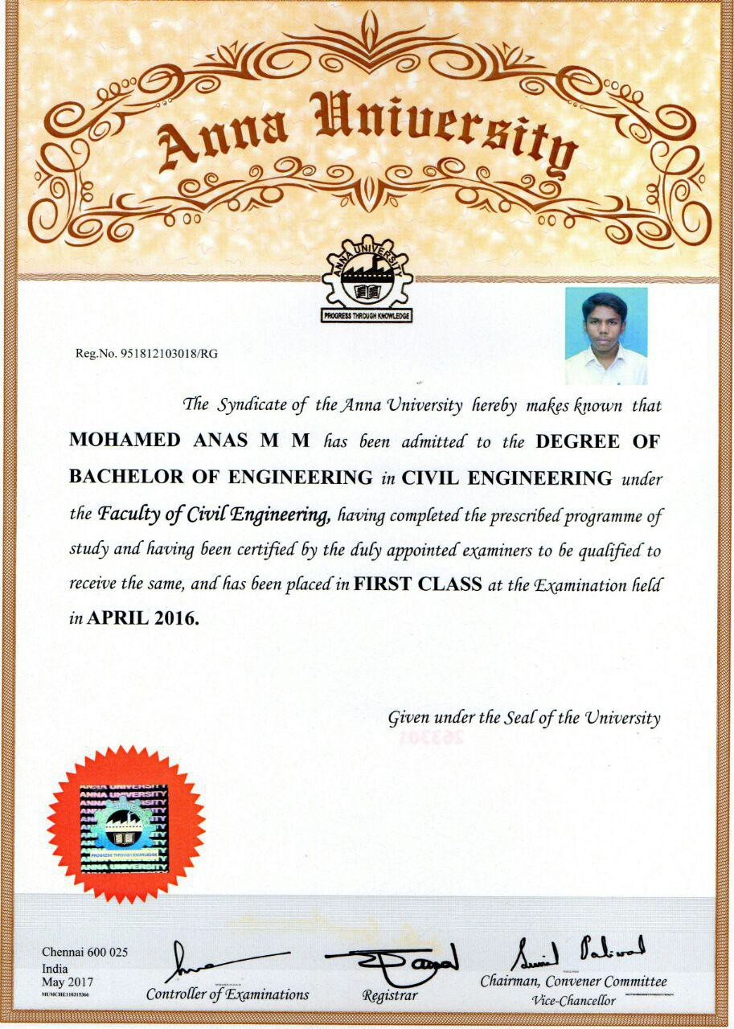

**EXPERIENCE CERTIFICATE SCAN COPY:**

