# Sajid Ahmad*

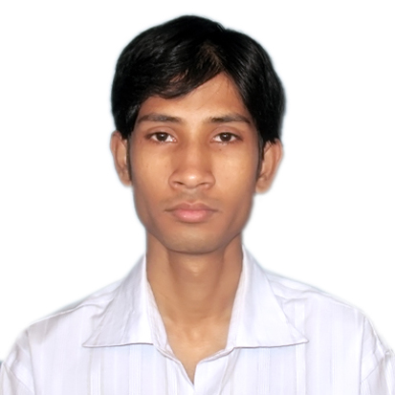

Contact: 09708148666

E-maiId: ahmad.sajid71@gmail.com

Ad: C/o Sahid Ahmad

H. No-3 Line no-1 Road no-1 B-Block Dhatkidih,

Jamshedpur, Jharkhand– 831001

**WASTE WATER TREATMENT PLANT OPRATOR**

**Goal**

Intention to excel in every sphere of life, exploit my full potential and knowledge acquired during the course of education and Technical career for benefit of the organization as well as for the personal growth, willing to work in a challenging and creative environment that inspires me to lead from the front.

**Qualification**

**Educational Qualification**

* Matriculation from J.S.E.B Ranchi in the year 2002.
* Graduation from Ranchi University in the year 2008.

**Technical Qualification**

Three Years Diploma in AUTOMOBILE Engineering from INDIAN INSTITUTE OF AUTOMOBILE ENGINEERING, JAMSHEDPUR session 2006 to 2009.

**Work Experience**

* Worked in **USHA MARTIN INDUSTRIES LIMITED** as a Water & Sewage Treatment Plant Operator during the period from 11th October 2013 to Till Date.

**Job Description**

* Responsible for the operation and maintenance of waste water treatment plant.
* As operator position decomposed all aspects of modern technological work in processing

Water for Industrial and other uses.

* Maintenance factor of equipments and proper checking of the plant equipment (before the operation), which often attached during treatment process such as (fouling, scaling, corrosion) etc.
* De-mineralization of water capacity 8 MGD, 9 MGD, 12 MGD and to check the correct balance of the cooling water chemistry i.e. (PH, Hardness, conductivity etc.) to avoid further disk-function of cooling tower or heat exchanger etc.
* To have close look on the filter and valve functioning while pumping and back washing process. Avoid water hammering etc. for smooth functioning.
* Position also decomposed in removing waste (solid material) and other impurities before cooling process to avoid further the mal functioning of the system and equipments.
* And also check the meter reading.
* Annually clean the raw water tank and related water tank.
* Annual open the sand filters or gravel filter and clean inside it.
* Co-ordinates and compares instructions, records analyzers, indication according to the laboratory analysis evaluation adjustments for records in hourly data.
* To check the previous shift report, checks the logbook for maintain the scheduled strategies.

**Computer Proficiency**

* Six month course in computer application from Sharptech Solution, Jamshedpur, (with MS Office, internet, HTML, Web page designing, with basic knowledge of computer Software,)
* Six month course in Autocad in Mechanical from Autodesk.

**Personal Information**

Father’s name : Mr. Sahid Ahmad

DOB : 18-07-1984

Nationality : Indian

Religion : Islam

Gender : Male

Language Know : English, Hindi, Urdu

Martial Status : Single

**Passport Detail**

* Passport no : J-3895868
* Date Of Issue : 18-10-2010
* Date Of Expiry : 17-10-2020
* Place Of Issue : Ranchi

I, hereby, state that all the aforementioned informations are true.

Date:

Place: Jamshedpur (Sajid Ahmad)