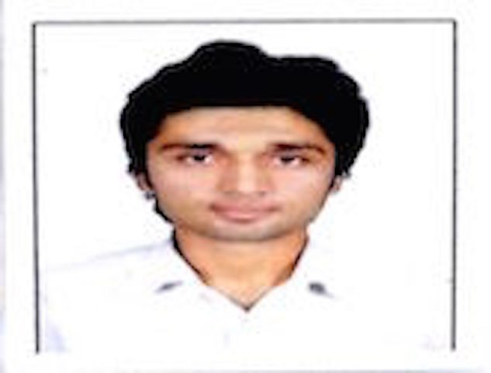

# PATHAN ATIFKHAN AIYUBKHAN

**Roll call** : 14BME085

**Contact (M):**7600660207

**Email** : [atifkhaninnovation@gmail.com](mailto:atifkhaninnovation@gmail.com)

**Address** : B-104, Al Arsh-3, Sarkhej, Ahmedabad: 380055

# OBJECTIVE

* To pursue a challenging career and be a part of progressive organization that gives a scope to enhance my knowledge and utilize my skills towards the growth of the organization”

# ACADEMIC QUALIFICATIONS:

|  |  |  |  |
| --- | --- | --- | --- |
| YEAR OF PASSING | QUALIFICATION | BOARD/UNIVERSITY | GRADE/ PERCENTAGE (%) |
| 2012 | S.S.C | G.S.E.B. | 86.40% |
| 2014 | H.S.C. | G.H.S.E.B. | 64.77% |
| 2018 | MECHANICAL ENGINEERING | NIRMA UNIVERSITY | 7.06 P.P.I.  9.00 S.P.I. |

**EXTRA CURRICULAR ACTIVITIES**

* Working For NGO (MAKE A DIFFERENCE -” MAD” )
* Participation in different Workshop (i.e.-ASME organized Gas Turbine Workshop)

# INDUSTRIAL TRAINING

* Summer internship at Wanakbori Thermal Power Station, Gujarat State Electricity Corporation Ltd.

# PROJECTS

* Increasing Efficiency of Centrifugal Pump
* Small Scale Biogas Plant
* Effect of Catalyst on Gasifier Performance
* Effect of Steam Injection on Performance of Downdraft Gasifier

# SOFTWARE SKILLS

* Autodesk product (AutoCAD, Mathcad, Inventor)
* PTC Creo
* ANSYS
* Ms Office



**PERSONAL DETAILS**:

**Father Mother Date of Birth Languages Hobbies**

**:** Aiyubkhan Pathan

**:** Anisa A. Pathan

**:** 11th March, 1997

**:** English, Hindi, Gujarati, German, Arabic

**:** Watching Documentaries, Playing Cricket, Getting explore to new things, etc.