TO DAY start

|  |
| --- |
|  |

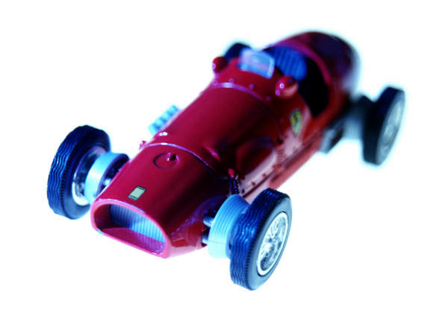

|  |  |
| --- | --- |
| INDUSTRIAL | EIECTRICAL TECHNICIAN |

CURRICULUM VITAE 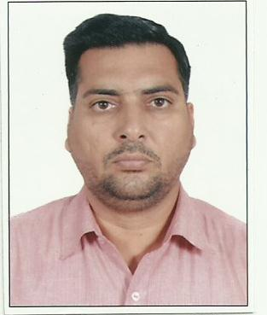

DILBAG SINGH

ELECTRICAL TECHNICIAN

**PROFESSIONAL SUMMARY**

More then 23 years experience 11 years in INDIA as a electrician and 12years in U.A.E. as

a Electrical Technician in the field of power plants, refineries , construction , control panels

and low volts voltage

work experience

1. NAME OF Company : M/S TARGET ENGINEERING CONST. CO. LLC

P.O. BOX NO. -32258 ABU DHABI U.A.E.

##### DESIGNATION / PERIOD ELECTRICAL TECHNICIAN ( 13TH MAY 2009 TO September 2012 )

RESPONSIBILITIES:

TESTING & PRE – COMMISSIONING OF ALL ELECTRICAL EQUIPMENTS AT EMAL ABU DHABI U.A.E.

ERECTION OF ALL TYPES OF PANELS , TESTING & COMMISSIONING OF PENELS , TRANSFORMER

ERECTION , GLANDING & TERMINATION OF ALL TYPES OF CABLES WITH ECL COMPANY FRANCE

AT EMAL ABU DHABI.

1. NAME OF COMPANY ALAIN GENERAL CONTRACTING CO. L.L.C.

( ALGECO ) P.O. BOX: 1017 ALAIN U.A.E.

##### DESIGNATION / PERIOD ELECTRICIAN ( MARCH 1997

##### TO DEC. 2006 )

##### RESPONSIBILITIES :

WORKED AS TEAM LEADER IN HIGHER TECHNOLOGY COLLEGE DUBAI , HIGHER TECHNOLOGY

COLLEGE FUJERAH , HIGHER TECHNOLOGY COLLEGE RAS AL KHEMA, DEFENSE CAMPUS AL AIN

SWIMMING POOLS CONTROL PANELS , LIGHTING CONTROL PANELS , FIRE ALARM CONTROL

PANELS , HOUSE WIRING & TROUBLESHOOTINGS AT SHAKH ZAEYD PALACE ALAIN.

1. NAME OF COMPANY KASHMIR ELECTRIC TRADING CO.

##### DESIGNATION / PERIOD ELECTRICIAN ( 1ST JAN 1993 TO 20TH FEB 1996 )

# PROFESSIONAL QUALIFICATION

PROFICIENCY CERTIFICATE IN ITI FROM NCFVT INDIA 1990 TO 1992

EDUCATION QUALIFICATION

MATRIC FROM PUNJAB SCHOOL EDUCATION BOARD WITH ELECTRICAL WIRING

1989 . BACHELOR OF ARTS FROM INDIA .

JOB PROFILE

A. TESTING AND COMMISSIONING OF ALL TYPES Of PANELS , TRANSFORMERS, GENERATORS.

B. GLANDING & TERMINATION ALL TYPES Of CABLES.

C. FABRICATION & INSTALLATION Of ALL TYPES OF CABLE TRAYS AND CABLE LADDERS .

D. ALL TYPES OF PANELS & TRANSFORMERS ERECTION.

E. TROUBLE SHOOTING OF VARIOUS MACHINES AND EQUIPMENTS.

SAFETY ATTRIBUTES

1. STRICTLY FOLLOW THE EFFECTIVENESS AND ISSUE OF THE PPE.
2. FAMILIAR With OIL FILED SAFETY REGULATIONS.
3. KNOWLEDGE OF PERMIT TO WORK .
4. ATTEND DAILY TOOLBOX & SAFETY MEETINGS

LANGUAGE KNOWN

1. English.
2. HINDI.
3. PUNJABI.
4. ARABIC.

|  |
| --- |
| PERSONAL DETAILS. |

Name  : Dilbag Singh.

Fathers Name  : Arjan Singh.

Nationality : Indian.

Marital Status : Married.

Date : apr 24, 1973.

Place Of Birth : Deron, Hoshiarpur.

EMAIL : [dilbagsingh24@gmail.com](mailto:dilbagsingh24@gmail.com)

: [dilbagsingh2496@yahoo.com](mailto:dilbagsingh2496@yahoo.com)

|  |
| --- |
| PASSPORT DETAILS. |

Number : j6980679 (OLD.P.P.A9224482)

Date Of Issue/Expiry  : 04/07/2011, 03/07/2021.

Place Of Issue   : Abu Dhabi, United Arab Emirates.

|  |
| --- |
| CONTACT NUMBER & ADDRESS. |

Dilbag Singh Arjan Singh, Village Deron Pin Code – 144527, District Hoshiapur.

Punjab, India, **Mobile :** 0091-95-30997496 (India) **Tel :** 0091-94-63156796 (India).

