**CURRICULUM VITAE**

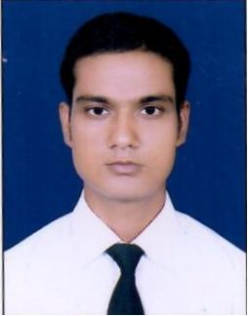**MOHD PARVEJ ANSARI**

**Address:**

H. No. 7 Kakrala

Badaun – 243637 (U.P.)

Mob. No.: +91-8273758482 & 9536401604

Email:mohdparveja786@gmail.com

**CAREER OBJECTIVE:**

* To utilize my knowledge in the development of the organization and achieve a significant position.

**ACADEMIC QUALIFICATIONS:**

* B.A. from M.J.P Rohil Khand University, Bareilly in the year 2012 with 2nd Division.
* Intermediate from U.P Board. in the year 2009 with 2nd Division.
* High School from U.P Board. in the year 2007 with 1st Division.

**PROFESSIONAL QUALIFICATION:**

* Diploma Accommodation Operation in Management (A.O.M.) from Food Craft Institute, University Polytechnic Campus, A.M.U., Aligarh in the year 2014.

**TRAINING:**

* Six months training in Hotel Clark Amer, Jaipur (Rajasthan) as Housekeeping And Front Office Department.

**COMPUTER QUALIFICATION:**

* 3 Months Computer Diploma in Tally.

**HOBBIES:**

* Listening Music and Playing Cricket.

**PERSONAL STRENGTH:**

* Self disciplined and goal focused.
* Enjoy in working time.
* Young, confident and responsible.
* Positive attitude, systematic and hard working.

**BASIC INFORMATION:**

Father’s Name : Mr. Shafi Ahmad Ansari

Date of Birth : 7th July, 1992

Gender : Male

Grew up in : India

Religion : Muslim (Sunni)

Height : 5.6

Marital Status : Single

Languages Known : English, Hindi and Urdu

**DECLARATION:**

* I confirm that information provided by me is true to the best of my knowledge and belief.

Dated:__________

**(Mohd Parvej Ansari)**

Place:___________