CURRICUL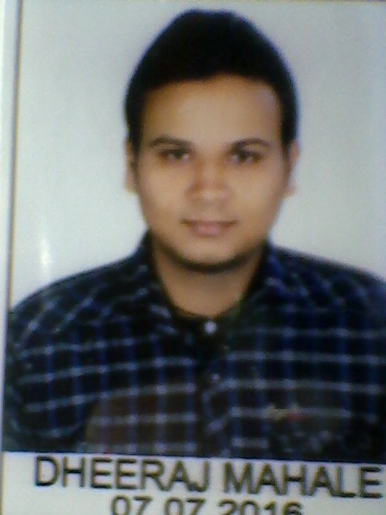AM VITAE

**DHEERAJ MAHALE**

**Mob: - 8770418851,8602211004**

**Email id:-mahale298@gmail.com**

**Career Summary**

To be a part of a team of a leading and innovative organization and contribute towards its growth and success using my potential skill set to the maximum.

Academic Qualifications

* **BE (mechanical) from Astral Institute of technology & Research Indore (M.P) with 6.95 CGPA in 2015**

**SEMESTER WISE CGPA**

|  |  |  |  |  |  |  |  |
| --- | --- | --- | --- | --- | --- | --- | --- |
| I -5.8 | II- 6.0 | III-6.19 | IV-7.38 | V-7.19 | VI-6.94 | VII-7.56 | VIII-8.44 |

* **SSC from Excellence School Govt .s.n.v.m no.2 Dewas (M.P) with 78.8% in 2009**
* **HSC from Excellence School Govt.s.n.v.m no.2 Dewas (M.P) with 86.4% in 2007**

**Technical Skills**

* + Software known: Auto Cad, Oracle Primavera P6 basic
  + Office suite: MS-office- excel, Power point .

* + Six Sigma yellow Belt from Vm Edu USA

Area of Interest

* + Manufacturing Technology
  + Automobile Engineering

**Minor Project**

* + Project Area : Braking System
  + Project Title : ABS Antilock Braking system"

**Major Project**

* + Project Area : Parking system.
  + Project Title : Automated multilevel Parking System "

**Industrial visits**

* + Liugong India Pvt. Ltd. Pithampur, Indore
  + Gajra Gears Pvt.Ltd Dewas ,M.P 455001

**Training and Workshops undergone**

**Implant training: Date -Jun/15**

* + **Organization : Gajra Gears Pvt. Ltd. Dewas. (M.P)**
  + **Duration : 15 days**
  + **Knowledge Gained : Learnt about various machining process**

**Experiences**

* 1year exp. in M/S Sunpharma as Project site Engg under M/S Mech N Tech Service Dewas ( M.P) and was working on a third party payroll from 2/16 to 1/17
* 2 month training in Sanghi Metal as Quality supervisor Dewas 9/17 to 11/17
* Currently working from 3/18 in Synergy school of business skills Indore as Project management trainee cum BDE

**Hobbies**

* Playing Badminton, Running
* Listening Music

Personal Profile

**Date of Birth : 26/12/1992**

**Gender : Male**

**Marital status : Single**

**Languages Known : English Marathi and Hindi (Read, write & speak)**

**Permanent Address : 44/2 Shimla Colony Dewas (M.P) 455001**

**Passport Status:. Available**

**I hereby declare that all the details furnished above are true to the best of my knowledge.**

**DATE: / / NAME : DHEERAJ MAHALE**

**PLACE: Dewas**

**. SIGNATURE:**