# CURRICULUM VITAE

# MOHAMMED SHAMSHER

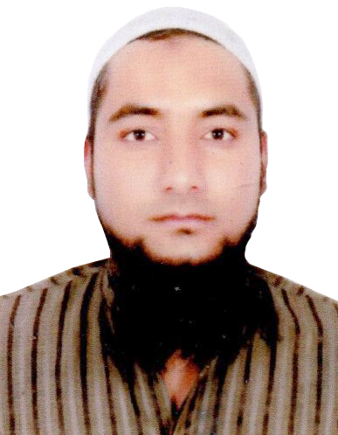AT – SUNDERBAN, PHASE – II,

H. NO. – 138, CHEPAPUL, MANGO,

JAMSHEDPUR, EAST SINGHBHUM,

PIN – 832110, JHARKHAND, INDIA

**Contact #: +91 – 9348466361 / 6204378412**

**E-Mail Id: - md.rkl1989@gmail.com**

Post Applied for: “**SAFETY OFFICER**”

**CAREER OBJECTIVE:**

* Seeking an assignment with an organization of repute which offers opportunity to utilize my skills and experience towards fulfillment of goals of the organization.

**ACADEMIC QUALIFICATION:**

* Passed **Matriculation** from **“B.S.E.O”, Orissa** in the year of **2005.**
* Passed **Intermediate** from **“J.A.C.”, Ranchi** in the year of **2009.**

**TECHNICAL QUALIFICATION:**

* One year **Diploma** in **“INDUSTRIAL SAFETY & FIRE MANAGEMENT”** from **“RASHTRIYA TECHNICAL INSTITUTE”, Jamshedpur** in the session from **June 2009** to **June 2010.**

**WORKING EXPERIENCE IN GULF:**

* Worked as a **“SAFETY OFFICER”** with **“PERFECT ARABIA”, Saudi Arabia** from **06th July 2013** to **31st March 2018.**

**WORKING EXPERIENCE IN INDIA:**

* Worked as a **“SAFETY SUPERVISOR”** with **“BALAJI CONSTRUCTION”, Jamshedpur** from **04th August 2010** to **25th May 2013.**

**PERSONAL DETAILS:**

* Name **:** **MOHAMMED SHAMSHER**
* Father’s Name **:** **MOHAMMED SHAMIM**
* Date of Birth **:** **17th May 1989**
* Nationality **:** Indian
* Religion : Islam
* Gender **:** Male
* Marital Status **:** Married
* Languages Known **:** English, Hindi, Urdu and Arabic

**PASSPORT DETAILS:**

* Passport No **:** **H - 6260833**
* Date of Issue **:** 19/08/2009
* Date of Expiry **:** 18/08/2019
* Place of Issue **:** **BHUBANESWAR**

**JOB RESPONSIBILITY:**

* Comply with safety law, norms and standards, work permit system safe work procedure.
* Coordinate the safety activities between the owner and Sub-contractor.
* Review and approve the sub-contractor's Safety procedure, advice and recommend any corrective measures.
* Be familiar with State and Statutory Legislation and site safety rules and guidelines.
* Making report and investigation of all near misses, incidents, or any accidents.
* Ensure that Personal Protective equipment Complies with all Standards Codes and regulations as per required by laws.
* Ensuring that safety equipments (incl. Fire-fighting equipment) are always ready for use, monitor expiry dates and inspection requirements.
* To prepare monthly HSE reports and check list and submit to client on date as agreed.
* To check the up keeping of tools, tackles, Lifting gears with the help of Companies.
* To promote safety consciousness at site among work force.
* Monitor and guide the workforce in the assigned area on general safety rules and safe work practices.
* Inspection for unsafe acts and unsafe conditions in the assigned area and report to HSE Manager.
* Confined Space → check entry permit before one enters confined space for adequate light and ventilation.

**Aim:** *Our main concern is to minimize the gap between the knowledge and implementation of knowledge while working. If we can fill this gap fully, we will be able to achieve the target of zero accident and then we can say “Our work area is SAFE”*

Date: ______________

Place: _____________ **(MOHAMMED SHAMSHER)**