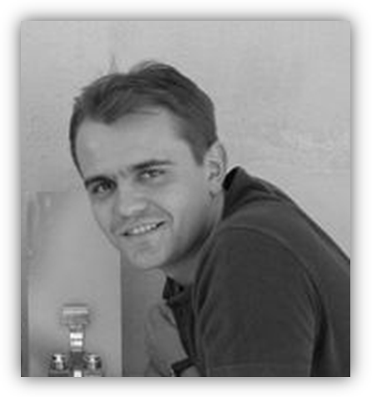 **Ákos Pohl**

*Chief Executive Manager*

*MSC in Civil Engineering*

**Present workplace:**

Civil Engineer, CEOS - Civil Engineering Optimal Solutions

H-1054 Budapest, Vértanúk tere 1., Hungary

Tel.: +36/30/242-30-92

Email: apohl@ce-os.eu

**Qualification:**

MSc diploma in civil engineering, BME

Postgraduate engineer economist, Corvinus

Member of the Chamber of Structural Engineering

(Checking Engineer Licence-TTTell)

 Associated Value Specialist

**Education:**

1991 – 1995 Technical Collage Pollack Mihály – Pécs – (high-school graduation)

1995 – 2001 Budapest University of Technology and Economics – Department of Structural Engineering

2003 – 2006 Corvinus University of Budapest - Engineer Economist postgraduate course

**Language:**

German intermediate C type language exam

English - good oral and writing skills

**Other qualification:**

AutoCad, MathCad, ArchiCad

Axis VM, Consteel, StruCad, Coop, Nemetschek

Microsoft Word, Microsoft Excel, PowerPoint

Driving license “B”

**Workplace:**

### 2009 – Chief Executive Manager, CEOS

### 2009 – Executive Designer, Star Seismic Europe Ltd.

### 2008 – 2009 KÉSZ Ltd., Design director (www.kesz.hu)

### 2007 – 2008 KÉSZ Ltd., Chief static designer

### 2001 – 2007 KÉSZ Ltd., Civil Engineer

### 2001 Meath Co. Council, Ireland (design)

2000 – 2001 Lindab-Butler Ltd. – professional practice (design and construction)

**Awards:**

### 2009 MAGÉSZ – Steel Award (ISD Dunaferr project)

### 2008 HEXAGON - Team award

### 2007 HEXAGON - Gordiusz award

**Main references:**

CEVA Phylaxia - production hall (Budapest)

TERRANOVA - mixing tower (Pilisvörösvár)

NATO - plane hangar (Kecskemét,Pápa)

BAT - production hall (Pécs)

BAUMIT - mixing tower (Alsózsolca)

Luxuri apartman house – monument renovation (Budapest - Vigyázó F. u.)

E-ON - gas cleaning project (Rotterdam - Netherlands)

EBS-IKW- powerplant project (Rüdersdorf - Germany)

RZR II.- powerplant project (Herten - Gemany)

ISD Dunaferr – mill project (Dunaújváros)

NESTLÉ – production hall (Lutzk-Ukraine)

KRONOSPAN – factories (Romania, Ukraine, Poland)

HOLCIM – cement factory (Nyergesújfalu)

BUDAPEST AIRPORT – new terminals (Budapest)

Date of Birth: Siklós, 27th Februar 1977

Nationality: Hungarian

Home Address: H-1119 Budapest, Hengermalom út 2/D, Hungary

Marital status: Married

E-mail: apohl@ce-os.eu

Phone number: +36/30/242-30-92