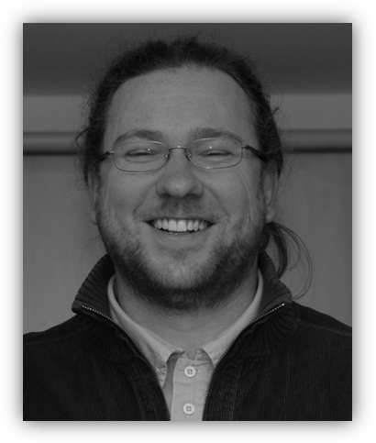 **Attila László Joó, PhD**

*External advisor*

*PhD Civil Engineer*

**Present workplace:**

Assistant professor, BME Department of Structural Engineering

1111 Budapest, Bertalan L. 2. Z./IX.

Tel.: +36/1/463-17-79

Fax.: +36/1/463-17-84

Email: ajoo@ce-os.eu

**Qualification:**

PhD in civil engineering, BME

**Language:**

English intermediate C type language exam

German elementary C type language exam

**Workplace:**

2008- Assistant professor, Department of Structural Engineering

2004-2008 Assistant professor, Department of Structural Engineering

2001-2004 PhD student, Department of Structural Engineering

**Research field:**

Experimental and numerical analysis of thin-walled steel structures. Stability analysis of arch bridges. Numerical modelling of steel joints. Virtual experiments based design. Earthquake analysis.

**Professional skill:**

Industrial, design and research and development projects at the Department of Structural Engineering. Remarkable projects:

Dunaújváros Danube bridge – member of the co-designer team, M=1:34 scale model test

M0 Highway bridge – member of the independent design team

Earthquake course for engineers, co-author of an Eurocode based book

**Research projects:**

2006-08 OTKA T062970, supervisor: Ádány, Sándor.

2006-08 TÉT project PORT-5/2005 (OMFB-01247/06): BME-Instituto Superior Téchnico, Lisbon.

2005-08 OTKA T049305, supervisor: Dunai, László.

2000-04 OM ALK 00074/2000 Ministry of Education R&D project: *Development of Lindab lightweight building system*, supervisor: Dunai, László, industrial partner: Lindab Kft.

**Awards and scholarship:**

2008 „Teaching of young researchers” award donated by the president of the BME

2008 Instituto Superior Téchnico, Lisbon, Portugal, supervisor: Dinar Camotim (2 months)

2003 Heriot-Watt University, Edinburgh, UK, supervisor: B. H. V. Topping (2 months)

2002 Light Gauge Metal Structures – Recent Advances, Udine, Italy (1 week)

2001 Advanced Studies in Structural Engineering and CAE, Weimar, Germany (2 weeks)

**Main references:**

Date of Birth: Budapest, 17th April 1978

Nationality: Hungarian

Home Address: H-1044 Budapest, Ady E. 16., Hungary

E-mail: ajoo@ce-os.eu Phone number: +36/30/210-27-54