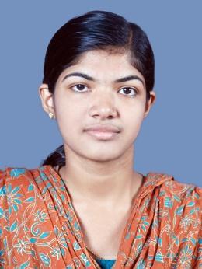NADUKKARA HOUSE THALAKODE P.O

PIN 686693 ERNAKULAM, KERALA PH: +919847336905

**BESSY BABY** . [Email:bessyb251@gmail.com](mailto:bessyb251@gmail.com)

# CAREER OBJECTIVE

To establish myself as a successful professional by executing my skills acquired from my academic qualifications, rich experience by personal approach to a given problem.

**ACADEMIC CHRONICLE**

|  |  |  |  |  |  |
| --- | --- | --- | --- | --- | --- |
| **Degree/ Course** | **Specialization** | **Institution** | **Board/ University** | **Year of Passing** | **Aggregate** |
| B.Tech. | Electronics and communication Engineering | Mar Baselios Institute of Technology & science[MBITS] | MG | 2014 | 66%  (1subject result awaiting) |
| Higher secondary | Science | ST.George HSS Kothamangalam | HSE Board, Kerala | 2010 | 82% |
| High school | ------------- | ST.Augstine GHSS Kothamangalam | Board Of Public Exam,Kerala | 2008 | 92% |

# SOFTWARE SKILLS

* MATLAB
* C
* MS Word
* Microprocessor And Microcontroller

# STRENGTH

* Flexible.
* Easily adaptable to the work environment.
* Responsible.
* Competent in working independently as well as in team



**TRAINING AND PROJECT**

* One week training at KELTRON
* One week training at TELK and KELL
* Final year project: FINGER VEIN RECOGNITION SYSTEM
* Mini project on LIBRARY MANAGEMENT SYSTEM USING RFID
* Seminar on topic :ARTIFICIAL RETINA USING THIN FILM TRANSISTORS



**WORKING EXPERIENCE**

**Administrative analyst / project coordinator in-charge** at 247DOC Healthcare Solutions Pvt. Ltd, Kalamassery

# (From September 2014 to present )

* + Plan, coordinate and evaluate activities associated with assigned project
  + Prepare, examine and analyze accounting records.
  + Prepare Daily work reports of employees.
  + Administrative works.

**PERSONAL PROFILE**

Father’s Name : BABY N.K Date of Birth : 11thDec1992

Age : 22

Marital Status : Single

Languages known : English, Malayalam Nationality : Indian

Religion & Caste : JS, Christian

Hobbies : Reading Books, listening music.

. Extra-curricular

Activities : 3 year college arts house captain, Anti-ragging squad

. member. Won prizes in school-college level

. Competitions

**DECLARATION**

I assure that the above furnished information is true according to the best of my knowledge and belief.

Yours sincerely, BESSY BABY



**REFERENCES**

1. Midhun Prakash Software developer

247DOC Healthcare Solutions Pvt. Ltd Ph. No:9846534089

1. Tinku Alias

Junior Software developer

247DOC Healthcare Solutions Pvt. Ltd Ph. No:9048362589