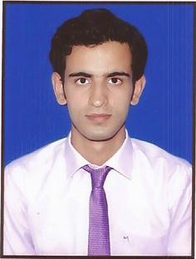**CURRICULUM VITAE**

PASTE YOUR RECENT PASSPORT SIZE FORMAL PHOTOGRAPH

* DO NO STAPLE

Rohit Tiwari

Mobile: +91- 9598611200

E-mail: tiwari.rohit99@gmail.com

**CAREER OBJECTIVE**

To have a growth oriented and challenging career, where I can contribute my knowledge and skills to the organization and enhance my experience through continuous learning and teamwork.

**EDUCATIONAL QUALIFICATION**

|  |  |  |  |  |
| --- | --- | --- | --- | --- |
| **Degree/Course** | **College/School** | **University/ Board** | **Year of Passing** | **% Marks** |
| B.Tech ME | Krishna Institute Of Technology, Kanpur | Uttar Pradesh Technical University | 2015 | 76.52 % |
| Intermediate | Kendriya Vidyalaya, Cantt, Kanpur | CBSE Board | 2011 | 59.2 % |
| High-School | Kendriya Vidyalaya, Cantt, Kanpur | CBSE Board | 2009 | 76.5 %  ( Honours) |

**TECHNICAL SKILLS**

* AutoCAD 2013, CATIA V5R20, CREO 2.0.
* Inventer 2013.
* Office Suite: MS-Office.

**PROJECTS**

* **MEGA PROJECT**
  + Title : Design and fabrication of Regenerative braking system.
  + Team Size : 07 members.
  + Description :It is to utilize the kinetic energy losses of a vehicle during braking and use this

energy for the charging of the battery.

**INDUSTRIAL TRAININGS**

* Organization : Honda Cars India Limited , Tapukara, Rajasthan
* Duration : 20th June 2014 to 20th July 2014.
* Description : “**Machining of Cylinder Head (petrol) on line”.**
* Organization : Krishna Institute of Technology, Kanpur
* Duration : 1st July 2013 to 31st July 2013
* Description : Worked on AutoCAD.

**INDUSTRIAL VISITS & SEMINAR**

* Bharat Heavy Electrical Limited (BHEL), Jhansi

**Objective:** To obtain a detailed and live demonstration of various stages of electric locomotive and transformer.

* Presented a seminar on “**Working of** **Diesel Hammer”**

**EXTRA – CURRICULAR ACTIVITIES**

* Certified Professional in Product Design by CAD Centre.
* Coordinated JUNKYARD in technical fest of the college.
* Won second prize in STICK STACK in technical event of the college.
* Worked as organizing committee in Anveshan (event in college).

**PERSONAL DETAILS**

Date of Birth : 10/12/1993

Father’s Name : Mr. Hari Chandra Twari

Mother’s Name : Mrs. Ragini Tiwari

Gender : Male

Languages Known : English & Hindi

Hobbies : Gardening and Basketball

Strengths : cooperative and keen observer

Permanent Address : 184, Hanumant vihar, Naubasta, Kanpur

Pin Code: 208021

**DECLARATION**

I hereby declare that the above mentioned information is true to my knowledge and I bear the responsibility for any incorrectness, if found in the above data.

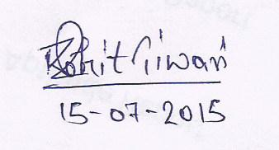

**Date: 15/08/2015**

**Place: BANGALORE (Rohit Tiwari)**