**Curriculum Vitae**

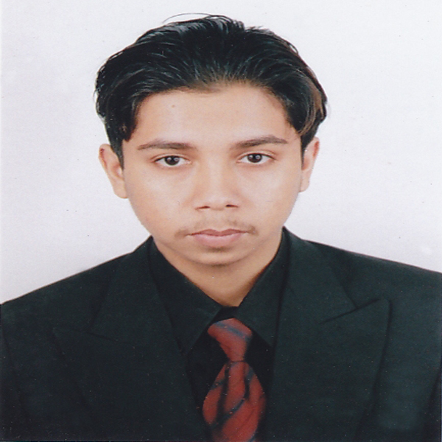

Sabbir Mahmud

Cell : +88-01771734566

+88-01617734566

E-mail : regan_580@yahoo.com

regan580@gmail.com

**Career Objective**

To develop my career through working in a well-known organization with honest and dignity where I can use my interpersonal skill, creativity and above all my learning experiences and where there is a scope to knowledge and contributes as well.

Name : Sabbir Mahmud

Father’s Name : Mohammed Abdul Al Baki

Mother’s Name : Sayeda Mongu Akter

Nationality : Bangladeshi.

Religion : Islam.

Sex : Male.

Marital Status : Married.

Date of Birth : 24th March, 1986.

National ID No. : 19863022909000011.

Passport No. : BM0207936.

**Contact Information**

|  |  |
| --- | --- |
| **Present Address** | **Permanent Address** |
| C/O: Rahim Regan Manson,  Nazir Road, Ward No. # 09.  Village: Barahipur.  P/O: Feni.  P/S: Feni Sadar.  District: Feni.  Bangladesh. | C/O: Rahim Regan Manson,  Nazir Road, Ward No. # 09.  Village: Barahipur.  P/O: Feni.  P/S: Feni Sadar.  District: Feni.  Bangladesh. |

**Academic Qualifications**

**S.S.C**

Institute : Bangladesh Embassy School, Riyadh, Saudi Arab.

Board : Dhaka Board.

Group : Science.

Year : 2003.

Result : GPA 2.88 out of 5.00

**Employment History**

* + Worked as a **Data Entry Operator** at Rashid Geotechnical & Material Engineers, Malaz, Riyadh, Saudi Arabia.

Duration: 4th April, 2007 to 24th November, 2011.

* Worked as a **Computer Trainer & Salesman** at Desh Computer, Somobai Super Market, S.S.K. Road, Feni Sadar, Feni, Bangladesh.

Duration: 5th February, 2012 to 10th January, 2017.

* Working as **Marketing & Supervisor** at Alo Convention Center, Hazari Road, Feni Sadar, Feni, Bangladesh.

Duration: 14th January, 2017 to till now.

**Computer Proficiency**

Office : Microsoft Office, Excel, PowerPoint, Access, Photoshop, Etc.

Internet : SEO, E-Mail Send & Receive, All Parts of Browsing, Etc.

Others : System Formatting, Installing, Assembling & Trouble Shooting.

Type Speed : 70-75 Words per minute in English & 25-30 Words per minute in Bangla.

**Language Proficiency**

Bengali : Excellent skills in Listening, Reading, Writing & Speaking.

English : Excellent skills in Listening, Reading, Writing & Speaking.

Arabic : Excellent skills in Listening & Speaking.

Hindi : Excellent skills in Listening & Speaking.

* Valid Saudi Driving License Available.
* Driving License Expiry Date: 19/12/2020

Date………….......... ---------------------------

Feni, Bangladesh. Sabbir Mahmud