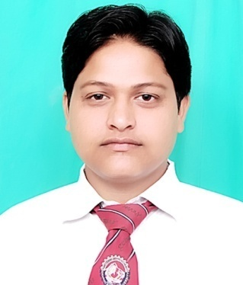

**Parmanent Address:**

**Moh. New Basti,**

**Jaspur,**

**p/o jaspur -244712,**

**U.S.Nagar, Uttarakhand.**

**SHAN E AALAM**

**B.Tech , Civil Engineering**

Contact No. : -9012775500

E-mail:- shaneaalam00@gmail.com

**CAREER OBJECTIVE**

To work in a firm with a professional work driven environment where I can utilize and apply my knowledge, skills which would enable me as a fresh graduate to grow while fulfilling organizational goals.

B**ASIC ACADEMIC CREDENTIALS**

|  |  |  |
| --- | --- | --- |
| **Qualification** | **Board/University** | **Year** |
| B.Tech (Civil Engineering) | Graphic Era Hill University, Bhimtal | 2011-2015 |
| Intermediate | U.K. Board | 2011 |
| High School | U.K. Board | 2009 |

**EXPERIENTIAL LEARNING (SUMMER INTERNSHIP PROGRAM)**

* + - **Office Name :-**  Public Works Department
    - **Project Title :- Flixible pavement constructions**
    - .**Duration :- 45 days**

**PROJECTS REPORT**

* **Flixible pavement consruction**

**COMPUTER SKILLS**

* Basic Auto CAD
* Internet Browsing

**CO-/EXTRA –CURRICULAR ACTIVITIE**

* Head of V.T.T.D.S at school level.
* Member of Event Organizing Committee in Graphic Era Hill University Bhimtal.

**ACHIEVEMENTS**

* Gate Qualified
* Business Skill
* Rajyapal Award.
* Actively participated in various sports activities for inter school & college.

**INTERPERSONAL SKILL**

* Ability to rapidly build relationship and set up trust.
* Confident and Determined

**PERSONAL DETAILS**

* **Name :- Shan e aalam**
* **Father’s Name :- Mr. Saeed Ahmed**
* **Date of Birth :- 16th March 1993**
* **Language Known :-** English, Hindi & Urdu
* **Marital Status :-** Single
* **Nationality :-** Indian
* **Interest & Hobbies :-** Internet browsing , Cricket

**DECLARATION**

I do hereby declare that the above information is true to the best of my knowledge**.**

**Place: JASPUR**

**(Signature)**