Curriculam Vitae

**OBJECTIVES**

Seeking entry level positions in a growth oriented company in the field of the infrastructure construction and consulting

**ACADEMIC QUALIFICATION**

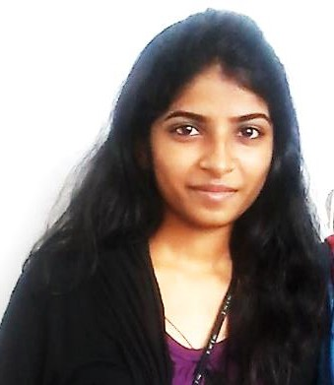

**ARDRA PRASAD**

Kg-3,146

Vikas Puri

New Delhi-110018

Phone: 9891423551 , 9650459770

E-mail: [ardraprasad93@gmail.com](mailto:ardraprasad93@gmail.com)

|  |  |  |  |
| --- | --- | --- | --- |
| **Degree/ Certificates** | **University / Institutes** | **Passing Year** | **Result (%)** |
| B.Tech in Civil Engineering | Sarabhai Institute of Science and Technology (CUSAT ), Trivandrum | 2015 | 70.5  (til 7thsem;  last year result awaiting) |
| Higher Secondary Certificate (HSC) | Kerala Public School (CBSE), Vikas Puri, New Delhi | 2011 | 77 |
| Secondary School Certificate (SSC) | Kerala Public School (CBSE) , Vikas Puri, New Delhi | 2009 | 77 |

 Resume: ARDRA

# ACADEMIC SEMINAR UNDERTAKEN

Topic: Performance of Zycosoil on the Pavements

# ACADEMIC PROJECT UNDERTAKEN

Project: Planning and designing of bus terminal cum commercial complex in East Fort (near Sree Padhmanabha Swami Temple), Trivandum

# PERSONALITY TRAITS

* Hard working, punctual and responsible
* Strong motivational and leadership skills
* Excellent communication skills
* Ability to perform under high pressure and against target deadlines

# COMPUTER KNOWLEDGE

* AutoCAD 2D
* STAAD Pro.
* Programming language: C , C++
* MS Office

# CERTIFICATION

AutoCAD 2012 Certified Professional

# ACHIEVEMENTS

* 1. Best KHO-KHO player of my school
  2. Performed dance in closing ceremony of Common Wealth Games 2011

 Page 2 | 8893246785

 Resume: ARDRA

# HOBBIES

* Gardening
* Playing badminton and caroms
* Internet browsing

# EXPERIENCE

Fresher

# PERSONAL DETAILS

|  |  |
| --- | --- |
| Name | : Ardra Prasad |
| Father’s name | : N.V Prasad |
| Mother’s name | : Sunita Prasad |
| Date of Birth | : 23-12-1993 |
| Nationality | : India |
| Sex | : Female |
| Marital Status | : Single |
| Language known | : English, Hindi, Malayalam  (speak, read and write) |

**DECLARATION**

I declare that the information and facts stated here in are true and correct to the best of my knowledge and belief.

 Page 3 | [ardraprasad93@gmail.com](mailto:ardraprasad93@gmail.com)