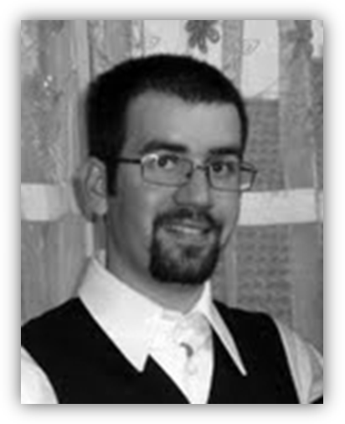

**Gazdus Henrik**

*Civil engineer*

*MSC in Civil Engineering*

**Present workplace:**

Civil Engineer, CEOS - Civil Engineering Optimal Solutions

H-1054 Budapest, Vértanúk tere 1., Hungary

Tel.: +36/30/863-04-28

Email: hgazdus@ce-os.eu

**Qualification:**

MSc diploma civil engineer, BME

**Education:**

1996-2004 Fényi Gyula Jesuit Secondary School, Miskolc

2004-09 Budapest University of Technology and Economics - Department of Structural Engineering

**Language:**

English intermediate C type language exam

English advanced A type language exam

German - intermediate C type language exam

Latin - reading and understanding

**Other qualification:**

AutoCad, MathCad

SteelExpress, Tekla, VB Express

Axis VM, Ansys

Microsoft Word, Microsoft Excel, PowerPoint

Driving license “B”

**Workplace:**

2007 Adeptus Plc. - professional practice (construction site management)

2008-09 Földvári Engineering Ltd. - professional practice (design)

2009- Civil Engineer, CEOS

**Research projects:**

2007 TDK Earthquake resistance sensitivity of industrial steel buildings, supervisor: Joó, Attila László and Dunai, László (2nd price)

2009 OTDK Earthquake resistance sensitivity of industrial steel buildings, supervisor: Joó, Attila László and Dunai, László (1st price)

**Awards and scholarships:**

2008 Bauhaus Summer Academy - Validation of Numerical Models, Weimar, Germany (2 weeks)

**Main references:**

Date of Birth: Miskolc, 27th October 1985

Nationality: Hungarian

Home Address: H-3526 Miskolc, Levente vezér utca 20., Hungary

Marital status: Married

E-mail: hgazdus@ce-os.eu

Phone number: +36/30/863-04-28