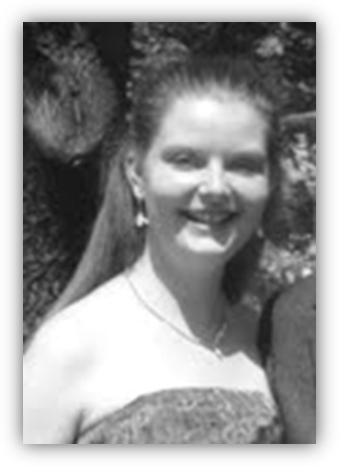

**Izabella Gazdusné Wusinczky**

*Civil engineering*

*MSC in Civil Engineering*

**Present workplace:**

Civil Engineer, CEOS - Civil Engineering Optimal Solutions

H-1054 Budapest, Vértanúk tere 1., Hungary

Tel.: +36/30/863-04-29

Email: [iwgazdus@ce-os.eu](mailto:iwgazdus@ce-os.eu)

**Qualification:**

MSc diploma civil engineer, BME

**Education:**

1996-2004 Fényi Gyula Jesuit Secondary School, Miskolc

2004-09 Budapest University of Technology and Economics - Department of Structural Engineering

**Language:**

English intermediate C type language exam

French - good oral and writing skills

**Other qualification:**

AutoCad, MathCad

SteelExpress, Tekla, VB Express

Axis VM, Ansys

Microsoft Word, Microsoft Excel, PowerPoint

Driving license “B”

**Workplace:**

2007- Adeptus Plc. - professional practice (construction site management)

2008-09 Földvári Engineering Ltd. - professional practice (construction)

2009- Civil Engineer, CEOS

**Research projects:**

2007 TDK Earthquake resistance sensitivity of industrial steel buildings, supervisor: Joó, Attila László and Dunai, László (2nd price)

2009 OTDK Earthquake resistance sensitivity of industrial steel buildings, supervisor: Joó, Attila László and Dunai, László (1st price)

**Awards and scholarship:**

2008 Bauhaus Summer Academy - Validation of Numerical Models, Weimar, Germany (2 weeks)

2008 Prof. Ottó Halász plaque for prominent professional and communal activities with the title of "For The Student of the Department of Structural Engineering"

**Main references:**

Date of Birth: Gheorghiu-Dej, 8th Februar 1986

Nationality: Hungarian

Home Address: H-1135 Budapest, Szt. László út 88., Hunga ry Marital status: Married

E-mail: iwgazdus@ce-os.eu

Phone number: +36/30/863-04-29