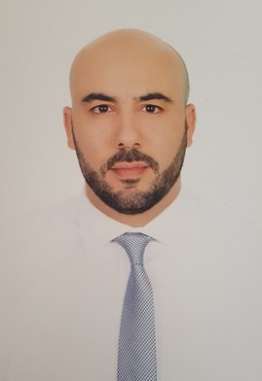

**Badr Zerradi**

**Customer Relationship Manager**

**34 years old, Married**

**Res Boughaz No 32 Mly Smail Tangier - Morocco**

**Mob: +212 684 208 322 Email :** [**bzerradi@gmail.com**](mailto:bzerradi@gmail.com)

## Summary

**A professional Banker with more than nine years of experience in Premier & Retail Banking Industry. A dynamic and driven Manager with solid reputation and track record in Relationship Management, Customer Service, Sales and Business Development. A demonstrated ability to motivate, manage and coach a team. Result-oriented person with proven ability to lead, innovate and manage resources in an efficient manner to meet and exceed targets**.

## Skills

**Interpersonal & Communication skills – Financial and analytical skills - Delegation - Strategic planning and thinking - Planning and execution - Problem solving - Change management - Leadership – Team management - Sales & business development - Relationship management – Customer service - Satisfaction and loyalty management - Negotiation - Risk management - Financial advisory & Wealth management.**

## PROFESSIONAL EXPERIENCEs:

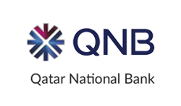(Doha)

Customer Relationship Manager January 2014 / August 2017

(Premium/Private banking)

Main responsibility:

* Manage a portfolio of about **200 High Net Worth Individuals HNWI** (Total assets under management AUM of more than **100 Million USD**).
* Build a Personalized Relationship with every customer and serve as the one-point contact for them in the bank.
* Provide customers a high standard quality of service and a unique customer service experience.
* Establish sales and business plans to ensure the growth of the portfolio and segment.
* Advise customers on managing their assets and provide them tailored wealth management solutions.
* Meet Revenue Targets and increase profitability by cross selling bank products especially **Investment solutions** and **Mortgages financing** locally and internationally.
* Increase retention and customer satisfaction index.
* Ensure the bank standards in term of risk, compliance, due diligence and AML (anti money laundering) are respected.
* Report to the Head of Customer Relationship Management.

Main achievements:

* Growth of the portfolio from 46 to 213 customers.
* Total AUM (Assets under management) increased from 20 to 100 Million USD.
* Total liabilities raised from 10 to 50 Million USD
* Customer satisfaction index increased from 69% to 98%.
* Sales targets achieved and exceeded.
* Nominated Staff of the year in 2015.

(Morocco)



***Une banque en phase avec les attentes de ses clients***

Branch Manager December 2010/Jun 2013

Main responsibility:

* Manage a branch of about 8000 customers (retail & SMEs accounts).
* Manage the day to day operations of the branch.
* Ensure policies and procedures of bank are respected.
* Manage all resources of the branch to meet customer’s needs and satisfaction.
* Ensure high quality service is provided to all customers.
* Establish Business plans, Sales and Marketing strategies to meet targets and increase revenue and profitability of the branch.
* Lead and motivate team members to achieve the sales targets and customer satisfaction standards.
* Train team members on operational risk, compliance, new products, campaigns & challenges.
* Present and promote the bank in the local community.
* Manage a team of 9 members and report to the Regional Manager

Main achievements:

* Total customers increased from 5000 to 8000 customers.
* Total assets raised from 10 to 20 Million USD.
* Total liabilities grew from 7 to 15 Million USD.
* Ranking of the branch moved from 13th to the 2ed position over 16 branches (ranking based on achievement of sales targets, customer satisfaction, risk and compliance management).

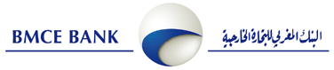

Branch Manager  Jun 2009/Nov 2010

Customer Service executive August 2007 /Mai 2009

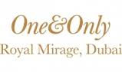

Guest Relations Coordinator October 2006/Mai 2007

## Graduations

Med sup Management School, Morocco 2011-2012

Master’s degree in Marketing & Sales

European Masters of Management & Business Strategy from the European Federation of Schools (Accredited by the IACBE-International Assembly for Collegiate Business Education).

High International Institute of Tourism of Tangier 2002/2006

(Morocco)

Bachelor degree in Hotels & Tourism Management

## Others

Certificates:

**Chartered Institute of Securities and Investment (CISI) Jun 2016**

International Introduction to Securities and Investment.

IT SKILLS: Ms Office (word, Excel, Power point), Outlook, Lotus

Languages: Trilingual: Arabic-English-French

Conversant in Spanish