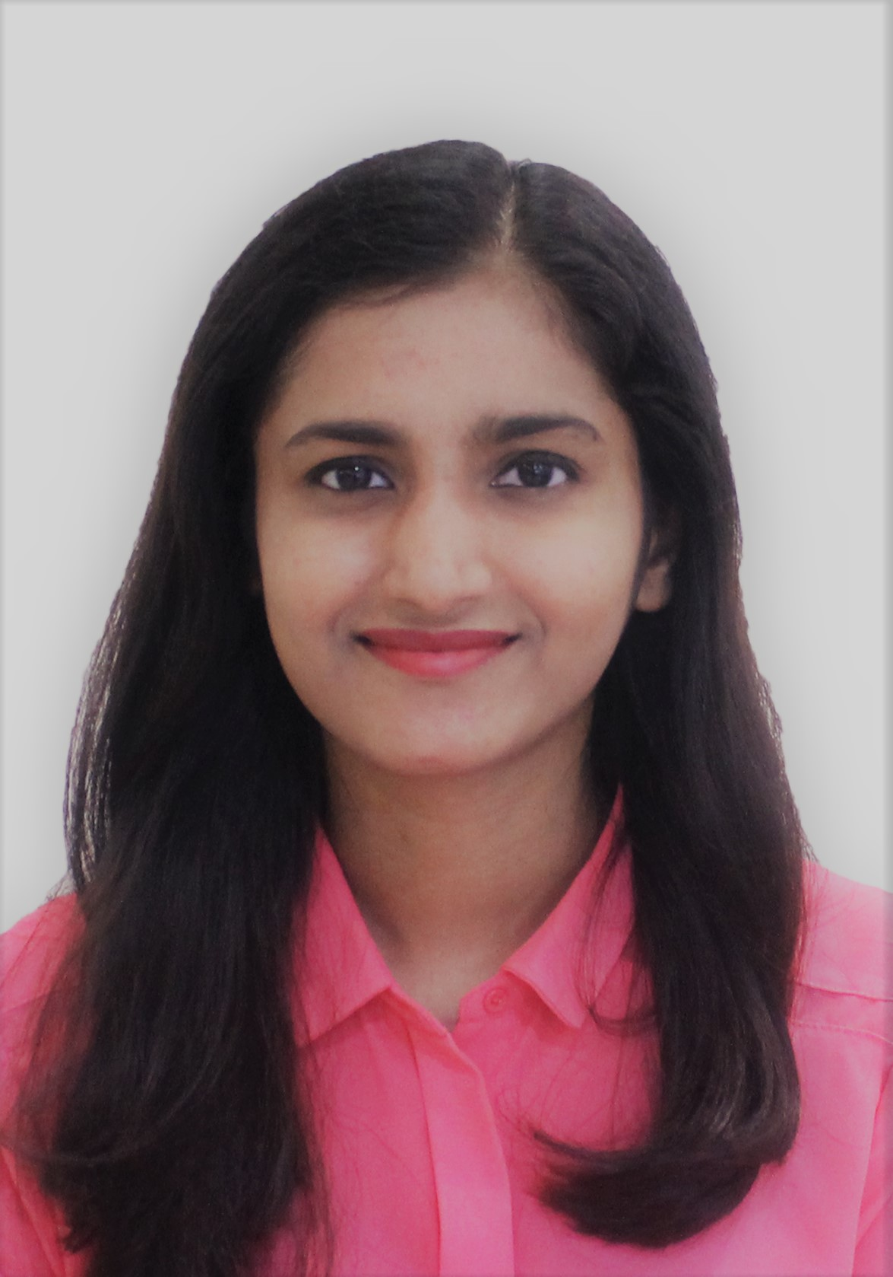

**Sobiya Saeed Ahmed Bhatkar**

Highly recognized in the community in Muscat, Oman. Given the chance, I can meet the challenges that your company will entrust me and begin my professional career in Oman.

**SOFTWARE**

Windows 10

SQL

EViews

IBM SPSS

**Education**

Languages: English

Hindi

Arabic

Urdu

**HOBBIES**

Music

Reading

Travelling

learning to use new software

ASIA PACIFIC UNIVERSITY

**(2016-2017)**

Master of Finance

Currently awaiting transcripts on completing Master of Finance degree from Asia Pacific University, Kuala Lumpur

FINANCIAL PLANNING COURSE

**(2015)**

Successfully completed an online course in Financial Planning from Sydney Institute of TAFE.

WALJAT COLLEGE OF APPLIED SCIENCES

**(2012 – 2015)**

Bachelors of Business Administration

I am a graduate in Bachelors of Business Administration from Birla Institute

Of Technology, Ranchi. I have also finished my Masters degree in Finance

from Asia Pacific University, Malaysia. I am aspiring to make a career in a

respectable firm where I can fully utilize my talents, personal and

communication skills which will help me grow eventually in a practical and fast-

paced environment.

**Experience**

Sales Representative, Abu Lubna Al Harthy - North Ghubra - Oman

**(January - December 2013)**

Key results:

* Achieved sales targets set during entire period of employment.
* Demonstrated resilience and ability to up-sell products.
* Significantly improved negotiation skills, regularly converting customers from point of enquiry to sale, something which earned me Sales Assistant of the period during the month of June.

**Managed Accounts at Mamun International Projects LLC– Sultanate of Oman**

***(2014 – 2015)***

**Managing Finance and Accounting at Bandar Community KL**

***(2017)***

(currently doing volunteer work)

**LANGUAGES KNOWN**

**CAREER**

**MUSCAT, SULTANATE OF OMAN**

**+968-92657528 |** sobibhatkar@gmail.com

**DETAILS**