# MOHAMMED JAVED KHAN

## telcobhpc@yahoo.co.in/ [telcobhpc@yahoo.co.in](mailto:telcobhpc@yahoo.co.in)

**7860701234/ 91-294-2430220**

Key Skills

Loan Disbursement Strategic Planning Recovery & Collections

Business Strategy & Execution New Business Development Strategic Alliances & Partnerships Profit Centre Operations Statutory Compliance

Team Building & Leadership

## Senior level professional offering over 21 years of experience with 14 years’ experience in Commercial Vehicle, Cars and Construction Equipment Finance.

Scaling new heights of success and leaving a mark of excellence in assignments which involve analytical capabilities and professional growth in Business Development & Expansion

# Profile Summary

Proficient in handling the collection operations for minimizing the delinquency level and accomplishing the assigned targets

Experienced in implementing the recovery strategies in case of payment defaults; understanding the reasons behind the default and accordingly providing options to regularize payment

Skills in streamlining customer services functions by designing innovative systems & processes to generate high value propositions for the customers

Ensuring early delinquency control, nonstarter management and skip tracing

Preparing collection plans, delegating the targets and developing overall and case specific strategies to recover money

Proven expertise in branch operations, ensuring effective management to accomplish overall corporate objectives

A competent professional with analytical bent of mind, customer- orientation with skills in back-end & front-end operations

# Career Timeline

**Sterling Lab, Bangalore as Manager Marketing**

**Hero-Motors, Udaipur (Rajasthan) as Sales Manager**

## May’96 to Dec’00 Jan’01 to Nov’01 Dec’01 to Jun’02

**Since Jul’02**

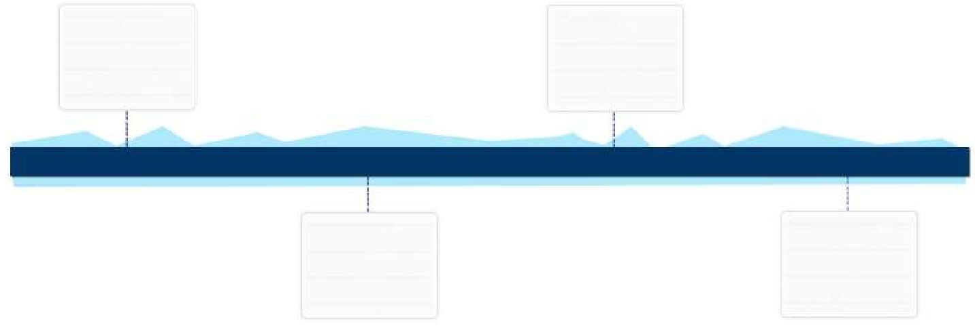

**ICICI Bank, Udaipur (Rajasthan) as Executive**

**Tata Motor Finance, Delhi as Deputy Vice President/Regional Collection Manager- Northern India**

# Education

Certification

MBA (Marketing) from Department of Management Sciences, Dr. Babasaheb Ambedkar Marathwada University, Aurangabad in 1998 with 64%

B.Sc. from College of Science Udaipur, M.L. Sukhadia University, Udaipur, Rajasthan in 1995 with 63%

Certificate Course in Computers from Center for Electronics, Design and Technology (CEDT) – Govt. Of India Enterprise, Aurangabad

Work Experience **Since Jul’02 with Tata Motor Finance, Delhi as Deputy Vice**

## President/Regional Collection Manager-Northern India

**Nov’10 till date**

Growth Path:

2002-2003-Area Manager –CG

2004-Sr. Branch Manager-North East 2005- Sr. Branch Manager-Jharkhand 2005-2007-Sr. Branch Manager-Rajasthan 2007-2009-State Head PV -Rajasthan 2009-2010-State Business Head-MP

2010-2014-State Business Head-CG & Vidharbha 2014 -2016-State Business Head-UP1

Since 2016 -Regional Manager Collections

## Key Result Areas:

Formulating effective collection & repossession and ensuring timely receipt of money from clients & recovery of bad debts

Excellence in execution

Micro level planning in terms of Product-wise market share, IRR and NPA, dealer relationship management & dealer channel funding, employee attrition control & employee productivity

Cross Sell products like general & Life insurance along with inventory funding to dealers, repossession, repossession Stock & yard management along with Auction ,refurbishment & enhancing resale price of the products, legal action planning on delinquent customers

Monitoring subscriber’s accounts & developing reports to ensure compliance with legal statutes & initiating strong legal action in case of continuous payment default

Supervising overall functioning of processes; ensuring compliance to the agreed SLA levels

Assessing customer feedback, evaluating the improvement areas & providing critical inputs

Rendering regular feedback to the collections team on the portfolio performance, quality of sourcing, turnaround and market trends

Liaising with various departments within organisation to gain support / resolve issues

Generating & analysing MIS reports in coordination with stakeholders to help them in decision making process related to churn control

# Previous Experience

## Highlights:

Best SBH (Profit centre Head ) Jharkhand in 2004 Best State head sales and collections in 2008

Best SBH (Profit Centre Head ) CG Vidharbha 2013 Best SBH(Profit Centre Head ) UP1 2014

Best Employee Manager In employee engamenet survey by Non Hewitt in 2014

High Scorer in Development centre by Non Hewitt in 2016 6 promotions in 15 years



## Dec’01 to Jun’02 with Hero-Motors, Udaipur (Rajasthan) as Sales Manager

**Jan’01 to Nov’01 with ICICI Bank, Udaipur (Rajasthan) as Executive**

**May’96 to Dec’00 with Sterling Lab, Bangalore as Manager Marketing**

Trainings Attended In-Plant Training from Lake Palace Hotel (Member of Taj Group), Udaipur



Rajasthan

Market Analysis of Cement Industries of South Rajasthan at J.K. Cement Works,

***Presentation Skills, Time Management, Telco Challenge Trophy, Out Bound Training Program, Winning Global Managers, World Wide View***

Nimbahera, Rajasthan

Analyzing the Growing Market of Audio Video CD Players of Videocon at Videocon International Ltd., Aurangabad

HRD and Welfare Activities in Videocon at Videocon International Ltd., Aurangabad

**Date of Birth:** 12th June 1973

Personal Details

**Languages Known:** Hindi, English, Marwari, Mewari, Gujrati, Marathi, French and Urdu

**Present Address :** Flat No. 1203, Ramses The Nile, Sector-49, Gurgaon

**Permanent Address:** 9 Paneri Upvan Fatehpura, Udaipur - 313001 (Rajasthan)