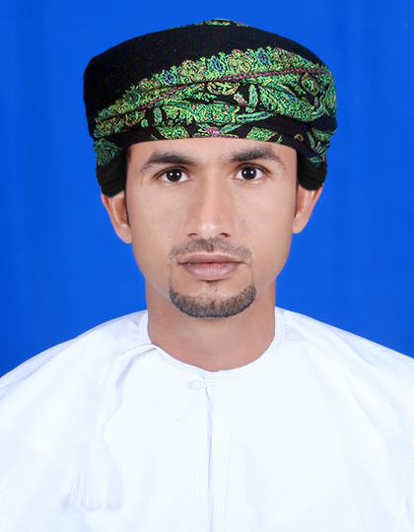**RUSTOM FAIZ MUHAMMAD AL- RAIISI**

Contact No: +968-96055460-99091517

E-mail Add: alraisirustom@gmail.com

# 

**Personal Statement**

Far away there in the sunshine are my highest aspirations. I may not reach them, but I can look up and see their beauty, believe in them, and try to follow where they lead.

**Objective**

To develop a career in a progressive organization by seeking a challenging position with an aim to contribute towards the objectives of the organization to the best of my capabilities in a dynamic, team oriented, competitive and cooperative environment, and to apply my professional skills to the real world problems while providing my services accomplishing tasks as per quality procedures within the given timelines.

**Work Experience**

HSBC-Oman Retail Banking Main Branch CBD Area, Ruwi (December, 2014 till date)

Job Designation- **Sales and Service Associate**

**Job Profile**

* Manages customer phone calls and visits from customer in a polite and friendly way.
* Takes ownership and initiative to complete necessary research and customer follow up or direct to the appropriate department for resolution.
* Offers value added products and services based on customer needs analysis and ensures customer understanding of those products.
* Provides excellent customer service to complex inbound customer calls by keeping up to date on training and internal communications.
* Tasked to handle multiple propositions for example, Advance, Premier, Insurance or multiple products for example Loans, Mortgage, Core Banking, Credit Cards.
* Generates customer loyalty though strong knowledge of key products and services.
* Take ownership and strives to resolve escalated customer calls and issues at hand.
* Knowledge of group compliance, Operation Risk, Retail Banking, Wealth Management and FATCA.

Zubair Automobiles- (April, 2013 to November, 2014)

Job Designation- **Service Advisor**

**Job Profile**

* Taking appointments
* Receiving customers
* Creating repair order
* Give customer estimation for cost and time
* Taking addition job approval
* Creating precise invoice
* Pre delivery inspection
* Delivery the vehicle
* Post service follow up
* Customer complaint handling
* Familiar with working on Autoline

Saud Bahwan Automobile- Toyota/Lexus (August,2008 to April, 2013)

Job Designation- **Representative Service Marketing & Service Advisor**

**Job Profile**

* Taking appointments
* Receiving customers
* Creating repair order
* Give customer estimation for cost and time
* Taking addition job approval
* Creating precise invoice
* Pre delivery inspection
* Delivery the vehicle
* Post service follow up
* Customer complaint handling
* Familiar with working on SAP

**Qualification**

* Higher Secondary School Certificate

**Competencies**

* Possess good Communication/Management /Interpersonal skills.
* Good command on SAP software usage.
* Good intellectual ability
* Communicates clearly
* Shows initiative
* Time Management
* Quality of work
* Encourages teamwork and collaboration among peers
* Effective personal presence
* Comprehensive problem solving and decision making ability
* Good Sportsman Spirit

**Computer Skills**

* MS Word
* Excel
* PowerPoint
* Adobe Photoshop

**Languages**

* Arabic
* English
* Balushi
* Hindi
* Urdu

**Personals**

Father's Name: Faiz Muhammad Al Raiisi

Nationality: Omani

Date of Birth: 14-02-1985

Marital Status: Married

Address: Mabellah South- Seeb, Sultanate of Oman.

**References**

It will be furnished on demand.