**Curriculum Viet**

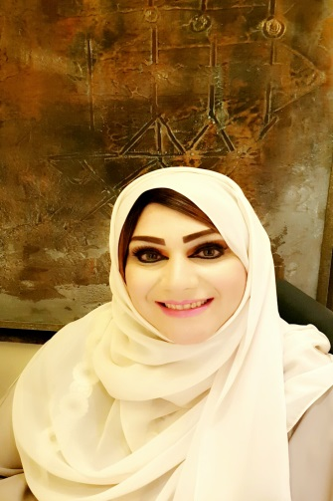

**Salama Said Al Habsi**

**Contact Info**

E-mail: [Salis.3017@gmail.com](mailto:Salis.3017@gmail.com)   
Mobile Phone Number: +96892101038  
City and State: Muscat, Oman

**Personal Information**

**Date of Birth:** 1978  **Gender:** Female **Nationality:** Oman **Driving License:** Yes since 2007

**Position Sought**

Financial, Administrative, clerical, marketing

**Educational background**

Diploma - Business Administration - Modern College of Business& Science

Foundation – Modern college of Business and Science

High school or equivalent, Arts Section  
Mudhaibi High School for Girls 1996

**Strength points**

The five most important is the best areas of excellence.  
• Accounting, Financial, administrative skills  
• Sales Support

• Active socially with excellent relations.  
• Customer Service

**Training and Certification**

Omani Institute for Vocational Training

• Certificate: Accounting NVQ Accounting  
• Duration: one year - (from September 1, 1996 to October 1, 1997)   
• the type of training: professional

**Skills**

* Computer: Level: Very Good
* Business Writing: Level: Good
* Accounting: Level: Excellent
* Communication and Public Relations: Level: Excellent

**Languages**

English: Level: Very Good  
Arabic: Level: Mother tongue

**Professional goal:**

To develop myself financially, professionally, and to complete my studies.

**Experience details**

1. **Sales Support**

**Saud Bahwan Auto group**

Location: Muscat, Oman, Wattayah  
Company sector: Automotive  
Job Role: Admin.  
October 2014 – May 2017.

1. **Sales Admin**

**Zubair Automotive**

Location: Muscat, Oman, Ghubra  
Company sector: Automotive  
Job Role: Sales  
October 2008 - April 2010

1. **Bank Clerk**

**Gulf Overseas Exchange**

Location: A’seeb, Oman,

Company sector: Financial Services  
Job Role: Accounting / Finance  
July 2007 - May 2008

1. **Assistant Accountant**

Horizon Group Health & Fitness

Location: Muscat, Oman,  
Sector company: Sports and Recreation  
Job Role: Accounting / Finance  
May 2005 - July 2007

**References**

**Upon request**