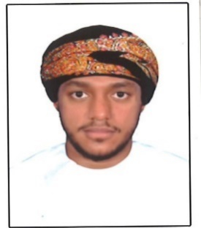**Salmeen Adam Salmeen AL Balushi**

|  |
| --- |
| **Personal Details** |

Date of birth: 22nd of August 1994

Place of birth: Al Sharjah, United Arab Emirates

Nationality: Omani

Marital Status: Single

Gender: Male Country of residence: Oman

|  |
| --- |
| **Objective** |

A young and ambitious fresh graduate is aspiring to be enrolled in a dynamic and a highly reputable organization to achieve the desired growth in his skill set, knowledge and career. Furthermore, making sure that my job position serves the company in a very efficient and effective way and working on results - oriented tasks to achieve the objectives of the organization and personal career goals.

|  |
| --- |
| **Educational Qualifications** |

- Bachelor’s Degree (Accounting & Finance), University of Birmingham, United Kingdom 2016

- High school secondary certificate, 12th grade from AL Ameer high school UAQ 2012

|  |
| --- |
| **Skills & Abilities** |

- Computer skills and usage of MS Office tools (Word, PowerPoint …), typing skills, Proactive

- Excellent interpersonal and communication skills (Written & Verbal), Email writing skills

- Problem- solving, Teamwork, ability to meet strict deadlines and thriving under pressure

- Time management, Fast learner, Adaptability and Flexibility, Attention to detail

- Customer service orientation, Hard worker, Self- motivated, Self- disciplined, Organised

|  |
| --- |
| **Languages spoken** |

Arabic: Reading, Writing, Speaking

English: Reading, Writing, Speaking

Can also speak and understand Hindi, Urdu & Balochi.

|  |
| --- |
| **Extra-curricular Activities & Hobbies** |

-Football -Swimming -Gym & Fitness - Socializing with friends & family -Outdoors

|  |
| --- |
| **Contact Details** |

Mobile Number: +968 9708 4056

E-mail address: salmin.adam@hotmail.com

|  |
| --- |
| **Home Address** |

House number 5563 AL Khoud, Muscat