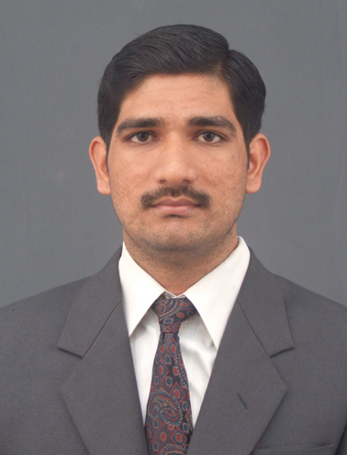

**Shajudheen N**

**Sohar ,Oman**

E [mail–nshajudheen@gmail.com](mailto:mail–nshajudheen@gmail.com), (M) +968-93580289

**OBJECTIVE**

Seeking a position to utilize my skills and abilities in a reputed organization that offers professional growth while being resourceful, innovative and flexible.

**About myself** Quick Learner

Hard Working

Team Oriented

**EMPLOYMENT HISTORY**

|  |  |  |  |
| --- | --- | --- | --- |
| Employer | Profile | Designation | Tenure |
| Oman Orix Leasing Company SAOG (Oman) | Service Industry Engaged with Financial Leasing | Sr.Officer  (Marketing ,sales & Credit ) | 2013-Present |
| Interlink Trading Company Qatar | Trading & Contracting  Company | Asst.Manager  (Marketing & Operation ) | 2011–2013 |
| NIIT Pvt Ltd.  Kerala, India | Leading Company engaged with IT Development & Training | Sr.Executive(Placement cell &Administration) | 2009-2011 |

**ACADEMIC QUALIFICATION**

|  |  |  |  |
| --- | --- | --- | --- |
| Qualification | Institution | % of Marks | Year |
| MBA (Finance & Marketing) | Guruvayurappan Institute of Management, Coimbatore | 64 | 2007–2009 |
| PG Diploma in Entrepreneurship Development Program | Guruvayurappan Institute of Management, Coimbatore | 58 | 2007-2009 |
| BBM | Hindustan college of Arts & Science, Coimbatore. | 60 | 2004-2007 |

**Job Profile**

**@ Oman Orix Leasing Company SAOG**

* Generating New Clients (Corporate & Individuals) (Direct marketing, Social Media, dealers network etc…..)
* Develop & Maintain long term relationship with Dealers in Oman ( Heavy & Retail Automotive, Machineries Dealers etc )
* Create individuals & Corporates Profile in Oracle system for their Financial Needs
* Review and analyses the customer credit, profile and making proposal for their financial Requirements
* Initial Approval has been done for their financial Needs
* Monitor credit portfolio quality and follow up on the delays. Take appropriate actions to improve the portfolio quality.
* Provide finance and market analysis and suggests opinion on credit risk
* Documentation & Execution process of the customers for their payments

**@ Interlink trading & Contracting ( Qatar)**

* Generating new clients.
* Conducting Marketing Activities.(Outdoor Advertisements, Trade fair Etc)
* Target fixing for the executives and lead them for achieving the goal.
* Manpower management.( coordination and transportation of manpower to the clients, coordination with the camp boss to ensure the camp is neat and hygienic)
* Recruitment of helpers and technical laborers specially electricians from Nepal.
* Handling executives in purchase and marketing of construction material products.
* Quotation review, finalizing the supplier, negotiation, handling client complaints.
* Supervise and controlling the direct purchasing functions such as product/service research, vendor selection, price and contract terms negotiation and purchase order completion.
* Handling all the documentation related with the Nepal embassy and recruitment agency.
* Verifying and approval laborers salary, leave, medical related issues.
* Handling the Delivery system of Products to the End user

**@ NIIT Pvt Ltd Kerala, India.**

* Handling Three centers in Kerala
* Conducting Marketing Activities.
* Generating job openings for the candidates
* Coordinate the flow of information related to placement from the H.O.
* Maintaining the data base of placement cell.
* Scheduling the classes for the faculty
* Handling recruitment for NIIT centers ( faculty,admin persons, business executive etc)
* Handling all administrative task ( public related activities, advertisement)

**Skills**

* Comprehensive problem solving ability.
* A team player and a leader with effective analytical and interpersonal skills in resolving issues.
* Team spirit, Adaptability, Commitment to grow, Initiative and Responsibility
* **Computer skills – Oracle, MS Office, Internet.**
* **Training Programmes Attended**
* **Participated in an Industrial training program** at **Sinicon Controls Pvt Ltd**, Kerala as a part Of **BBM** program.
* **Attended Marketing & Sales workshop as a part of current job**

**Project Details**

**During MBA: Summer Internship Program (SIP)**

Project Title: **A STUDY ON THE EFFECTIVENESS OF CUSTOMER COMPLAINT**

**HANDLING SYSTEM**

Project Area: **MARKETING** **(CRM)**

Company : **RUBFILA INTERNATIONAL LIMITED, PALAKKAD,KERALA,INDIA**

Duration : **1.5 Months**

**OBJECTIVES**

* To study the nature of customer complaints
* To find out the redressal of customer complaints by company
* To measure the customer satisfaction towards the service rendered by the Company
* To study the customer feedback towards after sales service

**PERSONAL DETAILS**

* Date of birth : 25th October 1985
* Sex : Male
* Marital Status: Married
* Religion: Islam.
* Nationality : Indian
* Languages known : English, Hindi, Malayalam, Tamil, { Arabic ( Read ,Write and Moderate level of speaking)}
* Hobbies: Driving, cooking, and motivating others.

**PASSPORT & LICENSE DETAILS**

* Passport No : H8131499
* Place of Issue : MALAPPURM
* Date of Issue :19 - 02 - 2010
* Date of Expiry : 18 -02 – 2020
* **Visa Status : Employment & Noc Will be obtained**
* **Driving license : Valid Oman &india**