**BIOGRAPHY**

**Dr. Kunal Aneja**

*M.B.B.S., M.S. (Ortho.), D.N.B. (Ortho.), Diploma Ortho. S.I.C.O.T. (Cape Town), F.A.G.E., M.I.M.S.A, Fellowship in Arthroscopy & Arthroplasty*

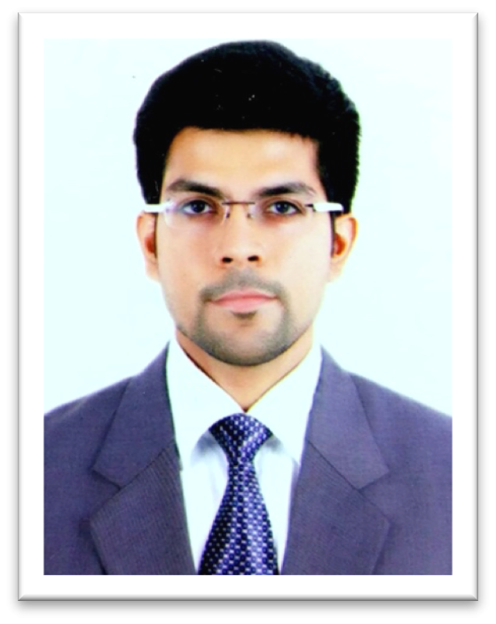

Dr. Kunal Aneja, completed his post graduate training from Sancheti Institute leading to M.S. Orthopaedics. He went on to successfully clear the National Board of Examination (N.B.E.) making him a Diplomate of National Board (D.N.B.) in Orthopaedics. He also succeeded in Diploma Orthopaedics Examination and was awarded Dip. S.I.C.O.T. (International Society of Orthopaedic Surgery and Traumatology) at Cape Town. He has completed his fellowship training in Arthroscopy & Arthroplasty at Ganga Hospital under aegis of Delhi Orthopaedic Association (DOA) and has been an awardee of prestigious SICOT meets SICOT International Fellowship at St. George University Teaching Hospital, Hungary. He has also been awarded the Asia Pacific Arthroplasty Society (APAS) International Travelling Fellowship 2018-19.

Renowned for his holistic approach, he has been extensively trained and specialises in management of complex trauma, sports injuries and joint disorders.

He currently serves as an Editorial Board member and Reviewer for numerous scientific journals of international repute. For his extensive research and academic experience, he has been awarded Memberships/Fellowships/Scholarships of various Societies and Young Research Investigator Award by Bone and Joint Decade – WHO in 2015.