**Career Objective**

To be a part of a progressive firm offering opportunity for career advancement and professional growth which will help me gain sufficient knowledge to use my talents for achieving the goals of the organization.

**Academics**

**DELLA JOHN**

|  |  |  |  |  |
| --- | --- | --- | --- | --- |
| Degree | Name of institution | Board of study | Year of passing | CGPA/  Mark in  % |
| B.Tech in Electrical & Electronics  Engineering | Viswajyothi College of Engineering &Technology | MG  university | 2016 | 7.32 |
| 12th | St.George HSS  Muthalakod  am | HSE | 2012 | 84.17 |
| 10th | Jai Rani public school  Thodupuzha | CBSE | 2010 | 85.5 |

# E-mail:

[dellajohn700@gmail.com](mailto:dellajohn700@gmail.com)

# Contact no :

Mob - 9495671912

Telephone No – 04862 242174

# Present Address :

KULANGARA (H) PURAPUZHA P.O THODUPUZHA, PIN :685583

# Personal Data :

Father’s Name :JOHN JOSEPH Date of birth : 03/01/1994 Gender : Female

Nationality : Indian Marital Status : Single

Languages : English,Malayalam

**Software training**

# Pursuing Software Testing Training from SPYROSYS Kochi

* Completed training in manual testing.
* Undergoing training in automation testing.

**Trainings undergone**

* Five days industrial training in KELTRON controls Aroor,Ernakulam.
* Three days training program on power communication- MPOWER,held at VJCET Vazhakulam.
* Industrial visit to power station at Pallivasal.

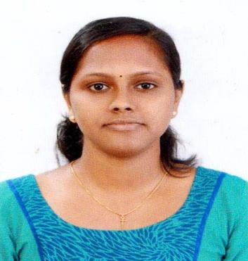

**Projects and seminar**

* + Main project:Multilevel automatic car parking system.
  + Mini project:VFD using microcontroller 8051.
  + Seminar:Power level distribution of radio base station.

**Achievements**

* + Won second prize in scrap squad contest in technical fest conducted by VJCET,Vazhakulam.
  + Participated in DHUANI’2015 at Kottayam for English skit competition conducted by M G University.

**Technical skills**

* Languages : C, C++
* Tools : Electrical CAD, Manual Testing, Automation Tool:QTP.

**Strengths**

* Adaptable and flexible.
* Team player.

**Interests and activities**

* Designing kurtas,singing,dancing.

**References**

1. Mr.Babu T Chacko,AsstProf.EEE Dept,VJCET,Vazhakulam Ph.+91-9656154572,email [id:babu@vjcet.org](mailto:babu@vjcet.org)
2. Mr.SharoneVarghese,AsstProf.EEE Dept,VJCET,Vazhakulam Ph.9895784663,e[mail id:sharone_varghese@hotmail.com](mailto:sharone_varghese@hotmail.com)

Place:

Date: **DELLA JOHN**