KOICKAL HOUSE, KADAVOOR [P.O] 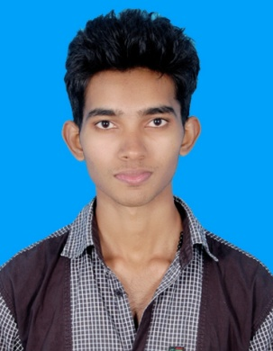

SOUTH PUNNAMATTOM, ERNAKULAM[DT]

+91 8281376685

ebindominic47@gmail.com

EBIN DOMINIC

|  |  |  |
| --- | --- | --- |
| Objective |  | Anxious to put my creativity and passion to work for a leader in the computer software industry, where I can maximize my ability to stay on the forefront of current needs and keep my finger on the pulse of today’s customers. |
| Skills & Abilities |  | * Interested in Social Networking * Skills in Video, Photo and Audio Editing * Ability to make decisions and solve problems. * Ability to work in a team structure. * Ability to deal with persons inside and outside the organization. * Interested in volunteering activities. * Ability to plan, organize and prioritize work. * Time management skill * Quick learner |
| achievements |  | * Best student award from Iype Memorial High School, kaloor of year 2008-09. * Passed SSLC examination with A+ grade for all subjects of year 2008-09 * Passed HSS examination from Computer Science with aggregate percentage 86 of year 2009-2011. * School and High School level prizes in Anchoring * Volunteer in different different programs |
| Education |  | B tech Degree from college of engineering munnar With aggregate percentage 55 Higher SECONDARY KERALA state board from st.joseph’s hss paingottoor With aggregate percentage 86 sslc KERALA state board from I.M.H.S KALOOR With percentage 90 |
| projects |  | SOCIAL NETWORKING(minor), ANDROID APP(major) (front end:asp.net, back end:mysql) |
| Communication |  | English, Malayalam, Tamil |
| SOFTWARE PROFICIENCY |  | * LANGUAGES: Basics in C,CPP, html. * SOFTWARE PACKAGES : Adobe Photoshop 7.0,Adobe Photoshop Elements 10,CORAL VIDEO STUDIO. * MS OFFICE: Word, Excel, Power Point, up to 2013 * Platforms: Windows 98,XP,Vista,7,8,linux,Ubuntu |
| PERSONAL PROFILE |  | Name Ebin Dominic Father’s Name Dominic K.A  Fathers occupation Agriculture  Mother’s Name Mercy Dominic  Sex Male  Religion Christian  Nationality Indian  Date of birth 04th November 1993  Permanent Address Koickal(H), kadavoor (P.O), South Punnamattom  Ernakulam-686671,Kerala  Phone +91 8281376685 |
| HOBBIES & extra curricular |  | Social Networking, especially facebook, LinkedIn, twitter, whatsapp etc.  * Movies, Radio, TV programs especially debates, interviews etc. * Cricket, Football * Placement volunteer * Part time jobs * Photography * Travelling, Driving * Swimming * Computer Games |
| REFERENCE |  | Dr.Shine N Das (HOD of CSE dpt, college of engineering munnar) phone: 9447006953  * Rev.Sr. Jyothis fcc ( Principal of SJHSS paingottoor) phone : 0485 2562181 |
| Declaration |  | I hereby declare that the above mentioned information is correct up to my knowledge and I bear the responsibility for the correctness of the above mentioned particulars. |
|  |  |  |

Place: Munnar

Date: Ebin Dominic