**RESUME**

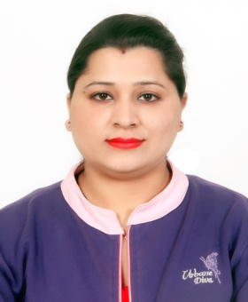 **VANDANA SHARMA**

**Banking with Indian Experience**

**D.O.B: 08-march-1990**

**Location: Punjab, India**

**Mobile: +91 9988372542**

**Email:** [**vandanas46@yahoo.in**](mailto:vandanas46@yahoo.in)

**Indian Passport no: L8076668**

# PROFILE:-

* Vandana Sharma is an accomplished senior financial Services Manager with four years of experience in **ICICI Bank Pathankot**, five months experienced with **INDUSIND Bank Pathankot** and currently working as a financial manager with **ASHWANI Imports & Exports Ludhiana**. She has proven success in organizing tasks, increasing sales and achieving the targets. Now looking for challenging and rewarding job opportunity, which explores inner talent to help me in emerging as a successful person in life.

**PROFESSIONAL QUALIFICATION:-**

* **University topper** in **Master in Business Administration** (M.B.A)

**International Business in 2012** from RIMT College, Mandi Gobindgarh affiliated to **Punjab Technical University**, Jalandhar.

**EDUCATIONAL QUALIFICATION:-**

* Graduation **B.com (Prof.) in 2010** from **Guru Nanak Dev** **University.**
* Intermediate in 2007 from **Punjab School Education Board**.
* Matriculation in 2005 from **Punjab School Education Board**.

**WORK EXPERIENCE:-**

* **Four** **Years Experience with ICICI bank** as a **Senior Financial Services Manager.**
* **Five Months Experience as a CSM with IndusInd bank.**
* **Now currently working as a financial Manager with Ashwani Imports & exports.**

**RESPONSIBILITIES AND ROLE DETAILS:-**

* Managing operations work of bank and dealing with all resident and non-resident high volume customers.
* Help the customers to get through tedious banking processes.
* Bring in new customers and open new accounts by advertising new services and boosting business referrals such as mortgages, insurances, loans, lending, etc.
* Coordinate with cashiers, tellers, including other internal and external bank employees.
* Sustain good relations with the clients.

**PERSONAL PROFILE:-**

HUSBAND NAME : - Mr. Gurpreet Singh

MARITAL STATUS : - Married

ADDRESS : - H.no 167, Near K.F.C School

Model Town Pathankot (Punjab) India

HOBBIES : - To Listening music & Net surfing LANGUAGES KNOWN : - English, Hindi & Punjabi

(Excellent reading, writing and speaking)

**Thanks & Regards**

**Vandana Sharma**