====================

**CURRICULAM VITAe**

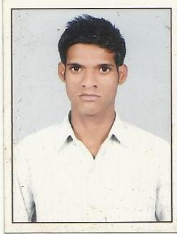

**SHAMIM ANSARI**

**Father’s Name :** Mr. MOINUDDIN ANSARI

**Address**  **:** B3/72 Vishwa Bank A.D.A Colony Naini,

Allahabad (U.P)

**Phone No**  **:** +91 9389712050

**E-mail**  **:** **sansari568@gmail.com**

**Career Objective:**

# To work in a challenging environment, demanding all my skills and efforts to explore and adapt myself in different fields, and realize my potential and contribute to the development of organization with impressive performance.

# 

**Professional Qualification:**

# 

# I.T.I. 2007-2008 (Machine Tractor) from U.P. Madarsa Board Govt. of U.P.

**Academic Qualification:**

# **12th from** U.P. Board in 2004**.**

# **10th from** U.P. Board in 2002**.**

**WORK EXPERIENCE:**

* ESPIEM (Kirloskar Diesel Engine) Pvt. Ltd. From 2008-2010
* Two year Experience in Mitsubishi Genset post of Service Engg.
* 1st Jan. 2013 to till date. I am working BULL Construction equipment authorized dealer NARAYAN EARTH MOVERS Pvt. Ltd. Allahabad.

**Current Salary:**

* Current : 9500

**Computer Skills:**

# Fundamental of computer

# Basic Knowledge of Internet.

**Strengths :**

* Time management & punctuality.
* Hard working and positive attitude.

**Personal Profile :**

**Name : SHAMIM ANSARI**

**Father’s Name : Mr. MOINUDDIN ANSARI**

**Date of Birth : 05-Jan-1989**

**Marital Status : Married.**

**Sex : Male**

**Languages Known : English & Hindi.**

**Permanent Address: LH-14 A.D.A. Colony Naini, Allahabad**

**Pin Code: 211008**

**DECLARATION:**

I hereby declare that the above written particulars are best of my knowledge and belief.

**Date: SHAMIM ANSARI**

**Place:**