**CURRICULUM VITAE**

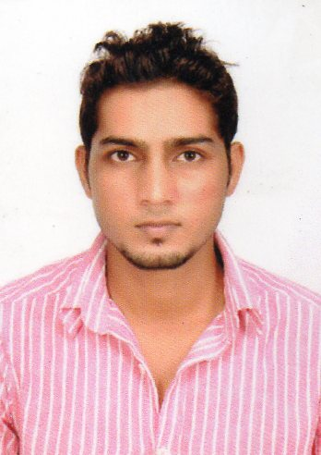

**Mohammad Majeed Alam**

Parmanent adreess

Address : Vill. Bhadeya, post bhadeya,

: P.S- barachatti, Distt. Gaya,

: Bihar, pin- 824201 INDIA

Mobile no : **0091-8754820458**

Email id : **mdmajeedalam1718@gmail.com**

**Post Applied For Chemical Engineer**

Objectives:

I want to apply my chemical engineering knowledge in this industry to develop my skills and learn more which will make me perfect for this company. I am looking a job as a Chemical Technician where my experience & abilities can be utilized more efficiently. I have the abilities to adopt my self to the job environment. I am confident that I will prove to be a useful addition to your renowned organization.

Educational Qualification:

### BE CHEMICAL

***2015*** ANNAMALAI UNIVERSITY, CHIDAMBARAM, TAMIL NADU

**. CGPA - 6.9**

### Senior secondary

1. MIRZA GHALIB COLLEGE, GAYA (BIHAR).

* 68% in 12th .

2009 GYAN BHARTI RESIDENTIAL SCHOOL, BODH-GAYA (BIHAR).

. 58% in 10th .

Trainng/Project Report:

Manufacture of **DI AMMONIUM PHOSPHATE (DAP) FERTILIZER.**

IT Proficiency:

* MS Word, MS Excel, MS Powerpoint
* MATLAB, AUTOCAD
* Languages – C & C++

Co-/extra curricular activities:

* Cultural secretary in Dept. of Chemical Engineering, Annamalai University.
* Participated in culturals and sports.
* Event organizing.

Skills:

Quick learner, can adjust with situation, leadership qualities, good visual memory, good in negotiation, curious and creative.

# Personal Profile:

**Date of Birth : 18th March 1993.**

**Nationality : Indian.**

**Religion : Islam.**

**Marital Status : Unmarried**

**Language Known : English, Hindi, Urdu, and Arabic (Tamil).**

**Passport Number : M 3392217.**

**Date of Issue & Place : 18th Nov. 2014 , (Patna).**

**Date of Expire : 17th Nov. 2024.**

**Hobbies:**

* **Reading news paper and articles**
* **Playing outdoor Games**
* **Listening to Song**

**DECLARATION:**

(Self safety and safe productivity is my first priority.)

I hereby declare that all the information furnished above is true to the best of my knowledge and belief.

**Thanking you, Place: India**

**Yours Trult , Date: 10-10-2015**

**Md Majeed Alam**