**CURRICULUM VITAE**  ____________________________________________________________________________________________________________

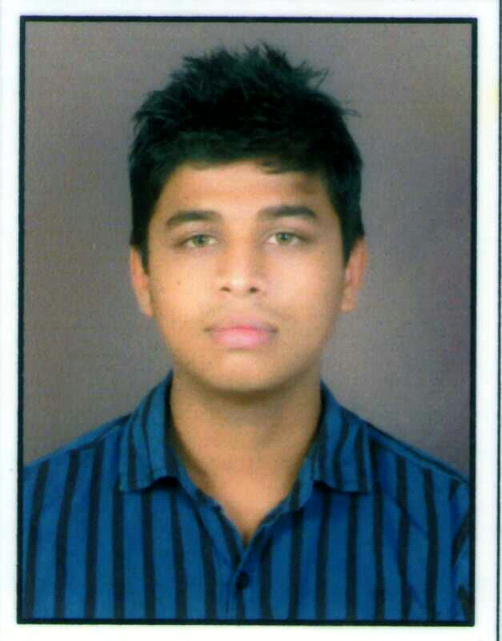

**Rathod Savankumar Kiranbhai**

**B.E.** **(MECHANICAL)**

**Email:**-savanrathod46@gmail.com

**Contact no:** +91 9687967987

**Career Objective:-**

Obtain a challenging leadership position by applying creative problem solving and learn management skill with a growing company to achieve optimum utilization of its resources and max. Profits.

**Academic Detail:-**

**Educational Qualification:**

|  |  |  |  |
| --- | --- | --- | --- |
| **QUALIFICATION** | **PASSING YEAR** | **BOARD/ UNIVERSITY** | **PERCENTAGE** |
| H.S.C. | March – 2010 | G.S.H.E.B | 44.42 % |
| S.S.C. | March – 2008 | G.S.E.B | 69.72 % |

**Current Academic Performance:**

|  |  |  |  |
| --- | --- | --- | --- |
| Mechanical Engineer | June-2014 | GTU | 7.28 CGPA |

**Semester Performance Index (SPI)**

**Cumulative Performance Index (CPI)**

**Industrial summer training:-**

I have visited ESSAR ,HAZIRA for one month and taken knowledge about rolling mill.

**Strength:-**

* Broad minded, Optimistic.
* Believe in Team Work.
* Eager to know new things.

**Personal Details:-**

**Name :** Rathod Savankumar Kiranbhai

**Education :** BE. Mechanical

**Father’s name and occupation :** Mr.Kiranbhai Rangilbhai Rathod,

BUSINESSMAN

**Date of Birth :** 21st MARCH, 1993

**Gender :** Male.

**Marital Status :** Single.

**Languages known :** English, Hindi, Gujarati.

**Hobbies :** Playing Cricket, listening music, reading book

**Address :** AT-Kareli, TA-Palsana, DIST-Surat,

Opp.telephone exchange,394310

.

**Declaration:-**

I hereby declare that the above mentioned information is correct up to my knowledge and I bear the responsibility.

**SAVAN.K.**

**RATHOD**