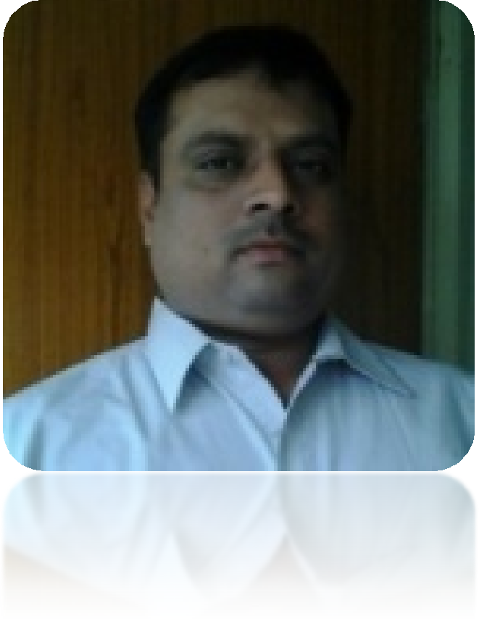Kumar Rajnish Anand E–Mail: [rajnishanand@hotmail.co.in](mailto:rajnishanand@hotmail.co.in) M: +91 9811806011 / 9560808866



Sr. Management Professional, Channel & Business Development Expert

~ Sales & Marketing ~ Strategic Planning ~ Business Development

Expertise in developing & implementing business strategies geared towards significant improvements in market share, innovation and profit maximization

PROFESSIONAL SUMMARY

Specialize in, sales & marketing , product management, new product development, new business development, product margin analysis, pricing, packing development, advertising, promotional system, product training , distributor management, sales forecasting, after sales service, branding strategy, brand protection, customer support, out sourcing projects, new projects, sales support, engineering quality failure analysis, team building customer relationship techniques, etc 13+ years rich experience in automobiles & auto components, automobile engineer.

Hard working, focused, good understanding of consumer behavior, ability to work under pressure, good product knowledge and managing abilities, new business development , team leadership, team building

to be at the apex of a professional organisation, steering its growth. I do aspire to reach there by hard work, loyalty and bottom line results.

AREA OF EXPERTISE & CORE COMPETENCIES



Sales & Marketing

Business Development

Product Launches / Promotions

ROI Accountability

People Managment

Corporate Social Responsibility

Area of Expertise



Program

Managment

Business

Dvelopment

Channel

Development

Peopale

Development

Resource

Development

Challenging

Permoting

Ownership

Relationship

Managing

Expectations

CORE COMPETENCIES

* Leading PAN India and regional cross – functional culturally diverse terms and finding solutions to business challenge
* Acting as on owner ambassador of the company and developing contacts in the industries trade associations, Business Partner, and Other Stockholders responsible for addressing business related matters.
* Supervising sales & Marketing, Strategic business planning, Finance & Budgeting and Operation Management. Developing business & commercial strategies and appointing reliable channel partners to ensure smooth business development.
* Pioneer the roll-out of PAN India launch including pricing, positioning key account management.

CAREER HIGHLIGHTS

Since Aug’14

With Climax Overseas Pvt. Limited AS Sr. Manager Sales – Aftermarket (PAN India)

July’10 to Aug’14

With PRS International Inc as Sr. Manager Business Development – Aftermarket (North & East India)

May’04 to June’10

With Apron Filters Pvt. Limited as Regional Manger – Aftermarket (South & West India)

Climax Overseas Private Limited

Gurgaon, Haryana - Sr. Manager Sales – Aftermarket Since, August 2014 Location: Gurgaon, Haryana. Area - PAN INDIA

Duties and Responsibilities

* Responsible respective customers
* Generation Collection of New (RFQ’S) Business Opportunity
* Responsible to achieve the sales target / Business Plan
* Develop and maintain strong relationship with customers
* Arranging customer visits to F-M locations as well as arranging F-M persons visit to customers
* Preparation reports and presentations for management meeting
* Channel development for Aftermarket
* Responsible for sales, business permeation and enhancing the market share of Company Products.
* Negotiating techno – commercial proposal with customer to solicit business
* To prepare annual business plan & start plan
* Coordinate with plant & SCM team for monthly schedules & capacity allocation so as to monitor share of business.
* Responsible for any other duty assigned by management

Accountabilities & Achievements:

* Defines and achieves territorial objectives
* Market intelligence and strategic contribution
* Achievement of primary and secondary sales target and growth objectives managements of

promotional budgets and costs forecasting accuracy for sale and inventory planning.

* Developing sales strategies to drive volume through team
* Responsible for discipline and quality assurance of entire team.
* Expansion Plan
* Lead, Train, and motivate the team for their personal as well as organizational growth.

Company Profile & Its Product:

* Climax Overseas Pvt. Limited is ISO/TS 1649/2002 certified manufacturer and supplier of all types of AUTOMOTIVE COMPONENT AND ASSEMBLIES. Climax Overseas Pvt. Ltd. Climax Overseas Pvt. Ltd serving the globe – exporting to over 30 countries from last 45 years

Product Dealing:

* Automotive & Industrial equipments such as in OE, Aftermarket and Corporate
* Climax overseas specialization Engine Mounts, Center Bearings, Trailer suspension component,

Assemblies and systems for Commercial and light commercial vehicle in overseas.

July’10 to Aug’14

With PRS International Inc as Sr. Manager Business Development - Aftermarket Location: Gurgaon, Haryana. Area – North & East India

Industries: Trading Auto component Highlights

* Successfully launch PAN India
* Strategic Planning & Management of Sales Division.
* Business Development in India & International markets.
* Branding the products & Image creation.
* Sales & Marketing.
* Commodity Trading & Market Analysis.
* Competitor & Trend Analysis.
* Market Penetration & Promotion.
* Planning Sales & Marketin Yearly/Monthly Budgets, Costs & Goals.

May’04 to June’10

With Apron Filters Pvt. Limited as Regional Manger – Aftermarket Location: Bangalore, Karnatka. Area – South & West India Industries: Manufacturing Automotive and Industrial Filters Highlights

* Manage Sales operations of the West Zone.
* Handling a team of 14 Executives all over West Zone
* Responsible for existing business through key customers / channel management / new business development
* Market mapping and market intelligence collation for relevant products range in india
* Channel expansion fro greater market reach
* Product positioning in market and value selling
* Liaise with product manager for all the sales promotion activities, with focusing business potentials
* Reporting sales forecast, rolling sales plan, visit reports, weekly and monthly plans, organizing local trade show.

Oct’02 to April’04

With Purolator India Limited as Area Manager – Sales & Marketing Aftermarket Location: Nagpur, Maharashtra. Area - Maharashtra

Industries: Manufacturing Automotive & Industrial Filters Highlights

* Driving new sales
* Delivery of revenue across all products
* Providing world class customer experience
* Recruiting & building sales Team
* Ensuring retention and up gradation of clients.
* Working closely with the compliance unit
* Needs to have a clear understanding of the internal and regulatory policies
* Ensuring implementation of all policies – In letter and in spirit
* Identifying quality resources who meet the desired benchmarks and hiring them
* Constantly driving results
* Timely goal setting and target setting. Ensure the entire unit is on the same page and is aware of the deliverables
* Constant monitoring of the unit’s progress and review against their targets
* Provide sufficient coaching and training to team members
* Empowering the team members to take informed decisions & grooming them to take on bigger roles

EDUCATION:

* Graduate – Bsc. ( Math) BHU Univ.
* Post Graduate - IT (Computer Science) MAHE Univ.
* PGDM - MAHE Univ.

PERSONAL DETAILS

* Date of Birth: Jan 06, 1979
* Address: Ashok Vihar, Gurgaon–122001,Haryana.
* Language: English, Hindi