**RESUME**

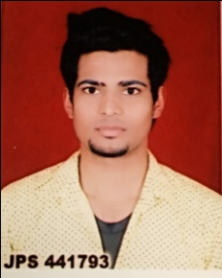

|  |  |  |
| --- | --- | --- |
| **ABHISHEK PAL**  **ContactNo**:  +91-8266998886/7088304333 |  | **ABHISHEK PAL**  **ContactNo**: +91-8266998886 |

**Permanent Address**

Sodi colony near Rudrapur railway station

Post-Rudrapur

Distt-U.S.Nagar(U.K) 263153

**CAREER OBJECTIVE**

______________________________________________________________________

An experienced person with good communication skills looking for an opportunity to contribute in success and profitability of the organization using my skills and experience***.***

**EDUCATION QUALIFICATION**

* 10th Passed from U.K Board in year 2009.
* 12th Passed from U.K Board in year 2011.
* B.Sc Complete from Kumaun university.
* M.Sc(Chemistry) apperaing.

**COMPUTER QULIFACTION**

* Basic complete ( M.S Word,Power point,excel)
* Tally 9.1
* Work in Networking Sites.

**PERSONAL PROFILE**

* Father`S Name : Mr. Ratan Singh Pal
* Date Of Birth/Age : 26/05/1994
* Religion : Hindu
* Gender : Male
* Nationality : Indian
* Marital Status : Unmarried
* Language Known : Hindi & English

**DECLARATION**

I hereby declare that all above information are true with the best of my knowledge.

Date: _____________________

Place: _____________________ **Abhishek pal**