**RESUME**

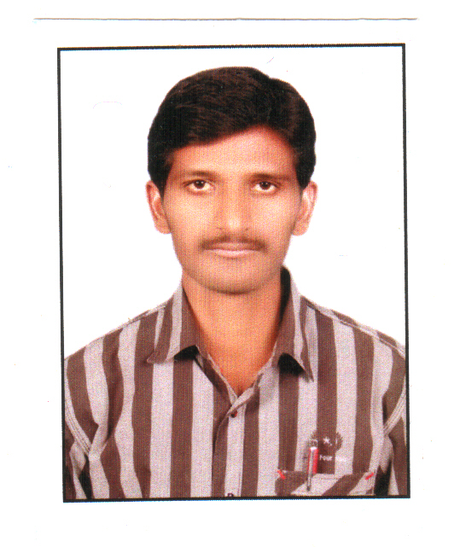**KESARI SANDEEP KUMAR**

H.No:12-72,Vill&Mdl: Yedapally. Dist: Nizamabad,

Telangana, India.

Mobile No: +91 9494162316

E- mail: kesarisandeepkumar@gmail.com

**Career Objective:**

rooeer Objective

I am Looking for an Opportunity in an Organization which can Provide me enough of Scope to utilize my Skills and Knowledge for the Growth of Organization as well as my Career.

**Educational Qualification:**

rooeer Objective

* Intermediate **(C.E.C)** from Board of Intermediate with an aggregate of 50%.
* **S.S.C** from **“Z.P High School”** Yedapally with aggregate of 75%.

**Technical Skills :**

rooeer Objective

* PGDCA
* Operating systems : Windows 2000, 2003, XP, Windows7, 8.1 and 10.
* Packages : Ms Office (word, excel, power point)

**My Strengths Are:**

rooeer Objective

* Self confidence.
* Thinking positively.
* Patience
* Learning new things

**Work Experience:**

rooeer Objective

* 2 years experience in SKS microfinance as a field assistant from 2010-2012.
* 4 years experience in M/S SRI MATA TRADERS ( Beedi manufacturing company) as a **STORE MANAGER & ACCOUNTED** from 2012 to 2016.

**Personal Details:**

rooeer Objective

**Name : KESARI SANDEEP KUMAR**

**Father’s Name :** Janardhan Goud

**Date of Birth :** 13-01-1991

**Gender :** Male

**Marital Status :** Married

**Nationality :** Indian

**Religion :** Hindu

**Languages Known :** English, Telugu & Hindi

**Passport no** **: K9452829**

**ISSUE DATE : 16/01/2013**

**EXP DATE : 15/01/2023**

**DECLARATION:**

I hereby declare that above information provided in this resume is real and true as the best of my knowledge.

**Date:**

**Place: Nizamabad.**

**(K *Sandeep Kumar*)**