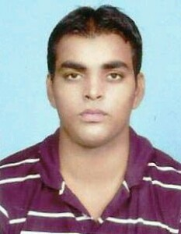**kamal kumar**

[**kumarnbj@gmail.com**](mailto:kumarnbj@gmail.com)

**9457407826**

**CAREER OBJECTIVE**

To utilize my skill which comleted sincerity and work hard towards building a challenging carrier in a growth oriented and leading edge organization that recognizes individual values and contribute towards smooth tunning of the organization.

# PERSONAL DETAILS

Address Moh. Adarsh Nagar Nawabganj

Date of birth 10/06/1992

Gender Male

Nationality India

Marital Status Unmarried Languages known Hindi & English

# EDUCATION DETAILS

|  |  |  |  |  |
| --- | --- | --- | --- | --- |
| Degree/Course | Institution | University/Board | CGPA/Percenta ge | Year of Passing |
| BA | MJPRU | MJPRU | 49% | 2016 |

**DECLARATION**

I hereby declare that all the above facts are true to best of my knowledge.



kamal kumar