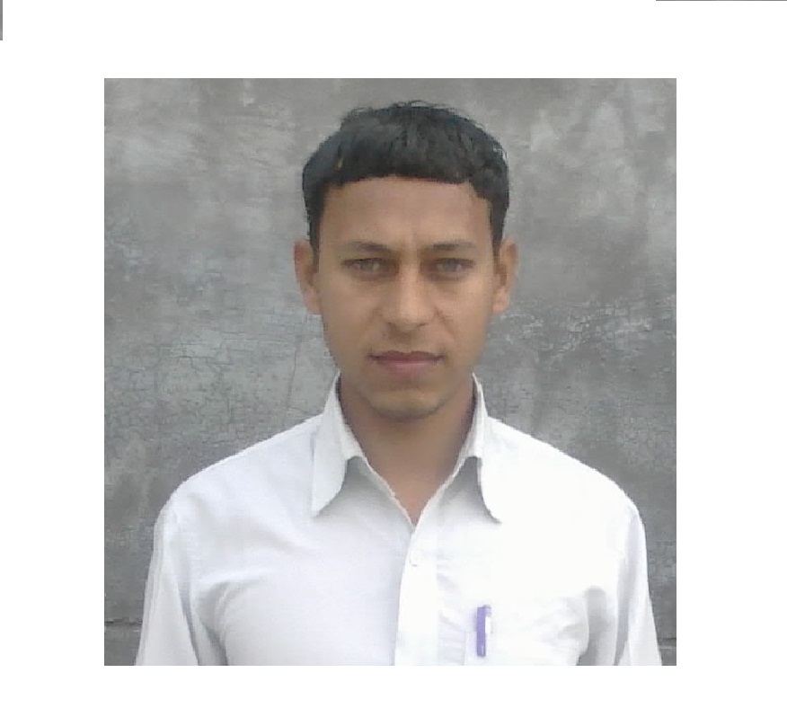**Resume**

**ANIL KUMAR**

Village – Paigambarpur

Post -- Satawara

Tehsil -- Debai

Pin Code -202392

Distt. -- Bulandsahar (U.P.)

Mob. -- 08954537801

Email -- rishvaanil@gmail.com

**CAREER OBJECTIVE:**

* I believe in sincerity, perfectionism and above all positive thinking, I value the job, which would give me an opportunity to apply my knowledge and provide me with an environment that stimulates learning.

**PROFESSIONAL QUALIFICATION:**

* Bachelor of Technology in **Mechanical Engineering** with 60% marks (2014) from **Uttar Pradesh Technical University, Lucknow**

**ACADEMIC QUALIFICATION:**

* High School (10th) from U.P Board, year 2006 with 62% marks.
* Intermediate (12th) from U.P Board, year 2010 with 60% marks.

**PROJECT TITLE:**

* **Project:**  Analysis of automatic transmission

**TECHNICAL SKILLS:**

* Auto CAD
* Summer training :

Machines:Lathes, Drill, Press,Grinder, Milling, Planing, Heat treatment.

CNC Machines

**EXPERIENCE:**

* Fresher

**PERSONAL INFORMATION:**

* Father’s Name : Mr. Uday vir singh
* Mother’s Name : Mrs. Shri Devi
* Date of Birth : 15/05/1989
* Nationality : Indian
* Religion : Hindu
* Sex : Male
* Marital Status : married

**DECLARATION:**

* I hereby declare that above mentioned information is correct and true to the best of my knowledge

**Dated (Anil Kumar)**