**Ghanshyam Patel**

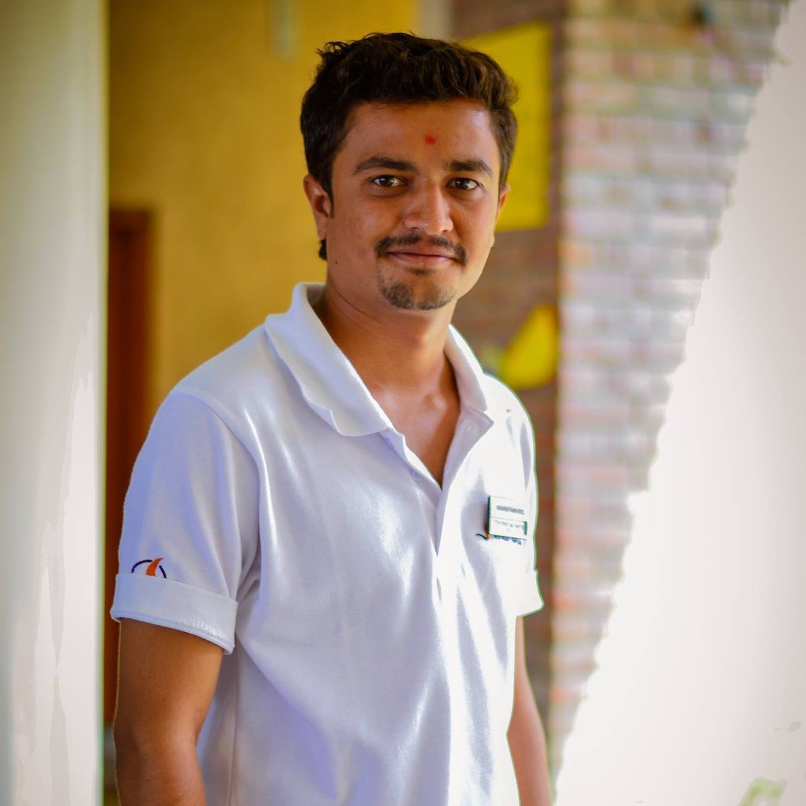

76, Gayatri Nagar, Dabholi Road, Surat-4, Pin-395004, Gujarat

**Email:** Ghanshyam.patel@jaipuria.ac.in; **Mobile:** 09033951896;

**Date of Birth:** 18th July, 1993

**WORK EXPERIENCE**

* **Flourish Pure foods Pvt. Ltd. ,** Surat, Gujarat **Feb’16 - Present**
* **Sales Executive – Institution Sales**

**Key Responsibilities:**

* Responsible for the identification of new opportunities and the initiation, development and deployment of new brands within/ outside existing families
* Identify process Improvement in Data Management and share the best practices among the team
* Maintain and document accurate information
* Timely and accurate delivery of regular business performance reports
* Develop basic management & consulting skills
* Sales Target Achievement.
* Daily, weekly, Monthly, Quarterly reports.
* Institution wise achievement.
* Finalizing beat plan.
* Customer's profiling.
* Create Availability to Institution.
* Maintaining customer data.
* Sending Activity report to NSM.
* Conversion and sales.
* Distributor appointment.
* Inventory management.
* Planning and monitoring of Team.

**SUMMER INTERNSHIP**

* **Hindustan Coca Cola Beverages Pvt. Ltd.**, Vadodara, Gujarat. **April’15-June’15**
  + Responsible for installation of Splash Bar Machine.
  + Survey on market development opportunities for Coca Cola: A Case of splash bar machine.

**ACADEMIC QUALIFICATIONS**

* **PGDM,** Marketing & IT + Operations, Jaipuria Institute of Management, Jaipur, 2016, **7.39/10**
* **B.E.**, BVM Engineering College, Gujarat Technical University, V. V. Nagar, 2014, **7.11/10**
* **Higher Secondary Schooling**, S.S.G.V., Gujarat Board 2010, **73.00%**
* **Secondary Schooling**, S.S.G.V., Gujarat Board 2008, **81.54%**

**ADDITIONAL PROJECT**

* Selling **Profit Club Card in Big Bazaar** (Future Group) **Jan’15**
* Understood the customer behavior regarding offers provided by Big Bazaar & marketing strategy of Big Bazaar.

**ACHIEVEMENTS**

* Chairperson of **Extra Curricular Committee**. **2015-16**
* Presented the paper titled “**Comparative Study on Brand Selection of Smart Phone in Youth through AHP: A Case of Rajasthan and Gujarat**” in UGC Sponsored National Conference on Emerging Trends & Challenges in Management held at Jai Narain Vyas University, Jodhpur. **Feb’15**
* Awarded with Certificate of Achievement in **Entrepreneurship week- India 2015** organized by National Entrepreneurship Network (NEN).  **Jan’15**
* Awarded ‘**Best Coordinator**’ trophy for coordinating **“Abhyudaya-2014”-3rd National Annual Fest** organized by Jaipuria Institute of Management, Jaipur. **Nov’14**

**CO-CURRICULAR ACTIVITIES**

* Organized many events at the **Fourth National Sports Meet 2015** at Jaipuria Institute of Management,Jaipur. **Sep’15**
* Worked as a crew member in **“Oyster Model United Nations Conference 2014”** as a Hospitality Executive. **Oct’14**
* Coordinated the back office work in **National Sports Meet-2014** organized by Jaipuria Institute of Management, Jaipur **Aug’14**