RESUME

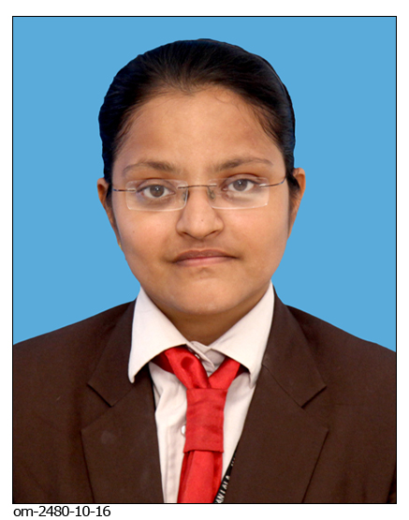

Name:- Ms. Kansara Priyanka Mukeshbhai

Address:-Near prajapati ashram,

kamla kiran building,

beside kanchan chemist,

charpul road, Navsari.

State:- Gujarat

E-mail:-priyankakansara4@gmail.com

Contact:- + 918460222010

**OBJECTIVE**

To seek an opportunity by which I can enhance myself & Company both development.

**EDUCATION QUALIFICATION**

|  |  |  |  |  |
| --- | --- | --- | --- | --- |
| **EXAMINATION** | **UNIVERSITY/BOARD** | **YR. OF PASSING** | **INSTITUTION** | **Final Year %** |
| M.B.A  (HR) | Gujarat Technological University, Ahmedabad | Pursuing | Naran Lala School of Industrial Management & Computer Science |  |
| B.Com | Veer Narmad South Gujarat University,Surat | 2014 | Naran Lala College of Commerce & Management | 52% |
| H.S.C | Gujarat Secondary & Higher Secondary Education Board,Gandhinagar | 2011 | D.D High School for Girls, Navsari. | 68% |
| S.S.C | Gujarat Secondary & Higher Secondary Education Board,Ganghinagar | 2009 | Sheth HiraLal Chotalal Parekh, Navsari High School | 48% |

**PROJECT DETAILS**

|  |  |  |  |
| --- | --- | --- | --- |
| Year | Company | Title | Place |
| Sep 2016 to till date | Ratnakala Diamond Export Pvt Ltd | A comprehensive Project On “To Study the Relationship between safety climate & Working Environment. | Navsari |
| 2016-17 | Naranlala Pvt.Ltd | Practice School Project-Sem 3 | Navsari |
| July 2016 | Laxmi Cine Magic[ Multiplex] | A Summer Internship Project on “A study of Consumer Behaviour towards Laxmi cine Magic in Navsari City” | Navsari |
| 2015-16 | D’ lords Export(India) Footwear | Practice school Project-Sem 2 | Navsari |

**ACHIEVEMENTS/AWARDS**

* Attended Workshop on “Soft skills” Carpe Diem 2015-16 IIM Calcutta Event in association with Make Intern held on 11/9/2015 to 12/9/2015 at Naranlala school of Industrial Management & Computer Science, Navsari.
* Participated in Singing Competition in "Xitij 2016" Youth Festival(Zonal level) by GTU.
* Participated in Group Singing Competition in "Xitij 2016" Youth Festival (Zonal level) by GTU.
* Secured B1 in Computer Proficiency test SCOPE held by Cambridge University.

**COMPUTER PROFICIENCY**

* Working knowledge of MS word, Excel, Powerpoint
* Working knowledge of some tools of SPSS

**CERTIFICATION**

* Tally ERP 9
* Scope

# HOBBIES

* Singing.
* Travelling

**PERSONAL INFORMATION**

Name : Priyanka M. Kansara

Gender : Female

Date of birth : 21/5/1994

Marital Status : Unmarried

Nationality : Indian

Language Proficiency : Gujarati, Hindi

|  |  |  |  |
| --- | --- | --- | --- |
| **Sr. no.** | **Title** | **Resource Person** | **Year** |
| 1 | Workshop on Import and Export Business, held at Naranlala college. | Mr. Chetan sir | 2016 |
| 2 | Seminar on Interview Skill by HDFC at Naranlala college | Mr. Mitul Mehta | 2016 |
| 3 | Seminar on Interview Skill by Indiamart at Naranlala college | Mr. Ambrish Dwivedi | Sep 2016 |
| 4 | Workshop on “Soft Skill” Organised by IIM Calcutta, with reference to Carpedien at Naranlala college | Dr. Datta Rokade | 2015 |
| 5 | Seminar on India in 21st century arranged by Navsari Management Assosiation | Mr. Firdose Vandravala | 4/3/17 |
| 6. | Seminar on Leadership lessons of Chanakya arranged by Navsari Management Assosiation | Mr. Radhakrishnan Pillai | 11/3/17 |

**SEMINAR/WORKSHOP**

**DECLARATION**

I hereby declare all the above information provided is true to my knowledge.

Date: 14/6/17

Place: Navsari

Sign

Priyanka M. Kansara