**RESUME**

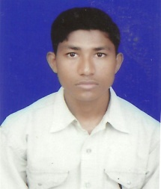

**NEERAJ KUMAR GUPTA**

Village& Post Patehara

Mob- +91-9104029339

9907612247

email- gupta3072@gmail.com

|  |  |  |  |  |  |  |  |  |  |  |  |  |  |  |  |  |
| --- | --- | --- | --- | --- | --- | --- | --- | --- | --- | --- | --- | --- | --- | --- | --- | --- |
| **CAREER GOAL**  To contribute best of my Knowledge, Skill and ability in the growth of the organization to achieve a sense of contribution by providing professional assistance.  **SKILLS**  .MS office (word, excel, PowerPoint, access), Internet, E-mails.  .Training and Communication Skills  .Eagar to learn from others  **EDUCATION**   |  |  |  |  | | --- | --- | --- | --- | | **Degree/Certificates** | **Institution** | **Passing Year** | **Percentage** | | BCA | Govt. T.R.S. College Rewa (MP) | APRIL 2014 | 63.97% | | Higher Secondary | M.P. BOARD | 2010 | 48.6% | | High school | M.P. BOARD | 2008 | 53.6% | |

**PERSONAL DETALLS**

Name Neeraj kumar gupta

Date of Birth 01/05/1990

Father's Name Panna lal gupta

Nationality Indian

Language Known English, Hindi

Marital status Unmarried

Permanent Address Village & Post Patehara Tehsil jawa

Distt.- Rewa (MP)

Pin- 486447

**DECLARATION:**

I hereby declare that the information given above is true to the best of my knowledge and belief.

**DATE:**

**PLACE: Patehara**