**HIMANSHU**

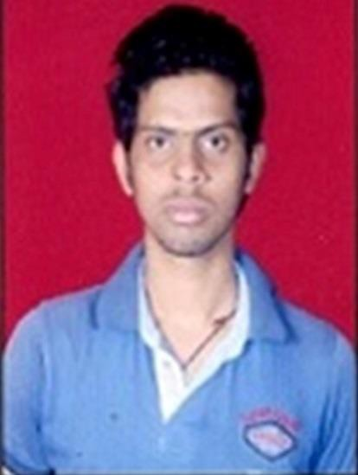

## Address:

S/o Shambhu Nath Vill.-Buksaura Post.-Dineshpur Dist.-U.S.Nagar Uttarakhand

PIN-263160

## E-Mail:

[*Mauryagreat14@gmail.com*](mailto:Mauryagreat14@gmail.com)[*Anshu885909@gmail.com*](mailto:Anshu885909@gmail.com)

## Mobile:

+918057026410

## Linguist abilities:

English, Hindi (Read, Write, Speak)

# Carrier Objectives:

To be an important member of engineering team in an organization that would provide me opportunities to develop, innovate and pursue a progressive career resulting in growth and success of both organization and self, utilizing my training as Mechanical Engineer.

# Strength:

* Sincerity, integrity and hard working.
* Basic Professional knowledge and

self-motivation.

* Ready to accept any challenge willingly.
* Dedicted and devotional to duty.

# Technical Qualification:

* 28 days summer training from Uttarakhand Transport Corporation.

# Qualification:

## Personal Data:

Father’s Name:- Mr.Shambhu Nath Mother’s Name:- Mrs. Saraswati Devi

D.O.B. : 07-04- 1995

Sex : Male

Marital Status : Single Nationality : Indian

## Hobbies:

Motor cycle Ridding. Car Driving.

Making collection of car and motorcycle facts.

* Passed B.Tech. from B.T.K.I.T. (An autonomous govt. Engineering Institute of Uttarakhand) in 2016.
* Passed 10+2 with 84% marks from CBSE Board in 2012.
* Passed 10 with 8.2 CGP from CBSE

Board in 2010.

# Declaration:

All the information provided by me in this resume is correct and I have not knowingly omitted any related information which would have a bearing on my employment with you.

Place: Rudrapur Yours Sincerely Date: 10th Dec, 2017 (Himanshu)