**CURRICULUM VITAE**

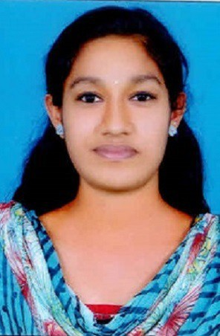

# ASWATHI JANARDHANAN

**Kizhakkan Kovval House Valiyapoil P O Cheruvathur VIA Kasargod 671313**

**MOB:+ 91-8078433981**

[**EMAIL:**yadavaswathi08@gmail.com](mailto:yadavaswathi08@gmail.com)

# CAREER OBJECTIVE

Hard working Person with proven Leadership and Organizational skills. To use my skills and knowledge in the best possible way for achieving company’s goals and to keep up with the cutting edge of technologies.

# ACADEMIC CREDENTIAL

|  |  |  |  |  |  |
| --- | --- | --- | --- | --- | --- |
| Course | Board/ University | Institution | Period | Month & Year of Passing | CGPA/  Percentage |
| MSc | Central University | Central University of Kerala | 2016-2018 | April 2018 | 81% |
| BSc | Kannur University | Government College Kasargod | 2013-2016 | May 2016 | 69% |

|  |  |  |  |  |  |
| --- | --- | --- | --- | --- | --- |
| HSC | Kerala State Board | GHSS  Cheemeni | 2011-2013 | March 2013 | 90% |
| SSLC | Kerala State Board | RHSS  Nileshwar | 2010-2011 | March 2011 | 87% |

**SOFTWARE CAPABILITY**

* Microsoft Power Point ,Word

**SKILLS**

1. Communication skill
2. Interpersonal skills
3. Leadership skill
4. Presentation skill

**AREAS OF INTEREST**

* Sedimentology
* Micropaleontology
* GIS and Remote Sensing
* Hydrogeology

**LANGUAGES KNOWN**

**English Malayalam Hindi Tamil**

* Working Knowledge of Windows and Internet
* Basic knowledge in ArcGis 9.3

# CO-CURRICULAR ACTIVITIES PARTICIPATED AND ACHIEVEMENTS

* + ‘Protolith’17, a national level technical symposium on geology & geo-physics organized by Indian Institute of Technology, Mumbai (October 2017).
  + National Seminar on “APPLICATIONS OF GEOSPATIAL TECHNOLOGY IN GEO- ENVIRONMENTAL RESEARCH” organized by the Department of PG Studies and Research in Geology’ Government College Kasaragod (December 2017).
    - National Seminar on “ EMERGING TRENDS IN SEDIMENTOLOGICAL RESEARCH” organized by the Department of PG Studies and Research in Geology, Government College Kasaragod (February 2016).
    - National Workshop on “APPLICATION OF OPEN SOURCE GEOSPATIAL TOOLS IN GEO- ENVIRONMENTAL STUDIES” held at the Department of PG Studies and Research in Geology, Government

College Kasaragod (October 2013).

* + - Poster Presentation on the topic “STRATIGRAPHIC SIGNIFICANCE OF WARKALLI FORMATION EXPOSED IN THE NORTHERN KERALA” at IIT Mumbai as a part of Protolith’ 17 (October 2017).
    - Volunteer in National Service Scheme. (2013-2016).

# FIELD EXPERIENCE

* Geological mapping around the Holenarisipur area Karnataka (March 2017)
* Geological Field work in the area around Angadimogar syenite, Ezimala gabbro- granophyres complex ,Perinthatta Anorthosite and Pazayangadi China clay mine (February 2017 as part of 2nd semester MSc geology).
* Geological Field work in several mines of Karnataka and Mysore.

**PERSONAL DETAILS**

**REFERENCES**

Date of Birth :08-03-1995

Gender : Female

Nationality : Indian

Marital Status : Single

Phone number :+918078433981

Father : C P JANARDHANAN

Mother : K VILASINI

# Dr. Sandeep K Asst. Professor

**Depatment of Geology Central University of Kerala Kasargod**

**Mob : 9048899470**

**Email**[**: sandeepk@cukerala.ac.in**](mailto:sandeepk@cukerala.ac.in)

1. **Dr. A N Manoharan Asst. Professor**

**Department of PG Studies and Research Govt. College Kasargod**

**Mob: 9447693860 DECLARATION**

I hereby declare that the information furnished above is true to the best of my knowledge.

**Place: Cheruvathur** ASWATHI JANARDHANAN

**Date:** 15-03-2018 