**RESUME**

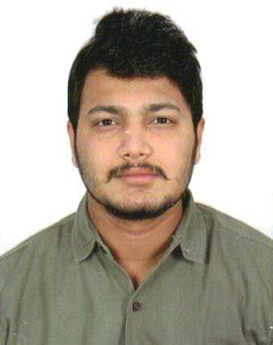

0

# MAUSAM BAGDE

Flat No 405, Vraj Vihar, Adajan Gam,Adajan.

Surat – 395009.

**Email:** [mausam764482@gmail.com](mailto:mausam764482@gmail.com)

**Cell No. :** +91 8319073635 / +91 896219222

## CAREER OBJECTIVE:

* Seeking a Competitive and challenging career and to serve the Organisation with my interpersonal abilities and consistence hard work.
* I want to become a successful person, where I can utilize all my potential for growth of Organisation.
* Self motivated and very efficient individual who can handle pressure is always organize.
* Always keen to learn more and acquire greater knowledge to the benefit of our Organisation.

## ACADEMIC QUALIFICATION:

|  |  |  |  |
| --- | --- | --- | --- |
| **EXAMINATION** | **BOARD/ UNIVERSITY** | **PASSING YEAR** | **%** |
| B.Com | CVRU | 2016 | 69.00% |
| 12th (H.S.C) | CBSE - DPS | 2013 | 56.00% |
| 10th (S.S.C) | CBSE - DPS | 2010 | 57.00% |

**EXPERIENCE:**

* + Worked in **Vodafone India, Surat** as a **Back Office Executive**

### for 1 Year.

* + Worked in **Hindustan & Petroleum Gas, Surat** as a **Back Office Executive** for 2 Years.
  + Presently working in **Yes Fashion Pvt Ltd,** Surat as an **Office Executive** for last 1 Year.

## COMPUTER SKILLS:

* + - Basic (M.S EXCEL,M.S WORD,DRAFTING MAILS & INTERNET)

## STRENGTH:

* Excellent Communication skill with Fluent English.
* Self Confidence.
* Positive Attitude.
* Willing to learn new things.
* Good Listener and Adaptable.
* Confident and Focus.
* Enthusiastic and Hard Working.
* Punctuality.
* Honesty.

## HOBBIES:

### Reading Novels.

* + - Listening Music.
    - Cooking.
    - Traveling and exploring new Places.

**PERSONAL INFORMATION:**

* + - Fathers Name : Shri D.R. Bagde
    - Date of Birth : 2nd February 1993
    - Gender : Male
    - Marital Status : Married
    - Nationality : Indian
    - Languages Known : Hindi and English

## DECLARATION:

I hereby declare that the above given information is truth in the best belief of my knowledge and if you will give me a chance to work under your kind control, I will try to satisfy you with my hard.

**Date:**

**Place: Surat**

**MAUSAM BAGDE**